Lead & Copper Rule Sampling Site Selection Guidance

The LCR established a “tier” system for selecting prioritizing sampling sites, and GA follows the same guidelines/regulations for sampling site selection.

Tier Criteria For Community Water Systems (CWS):
Tier 1 sampling sites are single family structures containing copper pipes with lead solder installed between 1/1/1983- 6/30/1988 or contain lead pipes and/or that are served by a lead service line.

Tier 2 sampling sites consist of buildings, including multi-family residences containing copper pipes with lead solder installed between 1/1/1983- 6/30/1988 or containing lead pipes and/or that are served by a lead service line.

Tier 3 sampling sites are single family structures w/ copper pipes having lead solder installed before 1983.

Tier Criteria For Non-Transient Non-Community Water Systems (NTNCWS):
Tier l sampling sites consist of buildings containing copper pipes with lead solder installed between 1/1/1983- 6/30/1988 or containing lead pipes and/or that are served by a lead service line.

Tier 2 sampling sites consist of buildings with copper pipes with lead solder installed before 1983.

Tier 3 Not applicable.

If a sufficient number of Tier 1 sites do not exist or are inaccessible, then Tier 2 sites should be used. And for CWS, if a sufficient number of Tier 2 sites do not exist or are inaccessible, then move to Tier 3 sites. Where there is an insufficient number (or none) of the tiered sampling sites that exist or that are available, then sites should be chosen throughout the distribution system that are representative of the type of plumbing used in the majority of the homes/buildings served by the water system.

Note: water systems should not monitor at sampling sites that have water softeners or point-of-use or point-of-entry devices for inorganic removal.

Once sites have been selected and monitoring begins, water systems should continue using the same sites originally selected for the required Lead/Copper monitoring, unless a site is no longer accessible or is otherwise no longer suitable or viable. Water systems on reduced monitoring on a less frequent basis and at a reduced number of sites should choose those sites from their original larger pool of selected sites.

Lead and Copper Routine Tap Monitoring Sampling Protocols

Samples should be 1-liter volume and collected as “first draw” from an interior regularly used cold water kitchen or bathroom tap/faucet for CWS or for NTNC a tap/faucet from which water is typically taken for consumption on a regular basis. Samples are either collected by a water system representative or by individual residents/homeowners.

After the sample is drawn, acidification of the sample should be completed by laboratory personnel upon receipt of the sample, but in no case later than 14 days after sample collection.

The following is an excerpt from our GA EPD State Lab Lead/Copper sample collection form showing the exact sampling instructions provided:

“This sample is being collected to determine the contribution of faucet fixtures, household pipes and/or solder to the lead and copper levels in tap water. This sampling effort is required by the Georgia Environmental Protection Division (EPD), and is being accomplished through the cooperation of homeowners and residents.

A "first draw" sample is to be collected after a short period of stagnant water conditions within the interior piping (i.e. no water use during this 6-hour period). Due to this requirement, either early morning (i.e. upon waking) or evening (i.e. upon returning from work) is the best time for collecting the sample. The collection procedure is described in more detail below.

1. Prior arrangements will be made with the customer to coordinate the sample collection. Dates will be set for sample kit delivery and pickup by the Water Department staff. If you use any water treatment devices (carbon filters, water softeners, reverse-osmosis systems, and distillers) make sure the Water Department is aware of this when you are contacted.

2. To correctly collect a "first draw" water sample, you must allow sufficient time between the last time used and collection time. Federal regulations require that a "first draw" water sample be collected from water that has been sitting in the interior plumbing FOR AT LEAST SIX (6) HOURS. There should be NO WATER USAGE PRIOR TO SAMPLE COLLECTION. Do NOT intentionally flush the water line before the start of the 6 hour period.

3. Use a kitchen or bathroom cold-water faucet for sampling, one that is regularly used for consumption. Do NOT remove the aerator prior to sampling. Place the open one (1) liter sample bottle below the faucet and turn on the cold water tap as you would to fill a glass of water. COMPLETELY FILL THE SAMPLE BOTTLE.

4. Tightly cap the sample bottle and place in the sample kit provided.

5. Place the sample kit outside the residence in the same location it was delivered for the Water Department staff to pick up. Do not mail the sample kit to the laboratory directly. This will be handled by the Water Department.

6. Water system, mail the sample kit to the following address:
EPD Laboratories
5804 Peachtree Corners East
Norcross, GA 30092

7. Results from this monitoring will be provided to participating customers when reports are generated by the Georgia EPD. Immediate notification will be provided when excessive lead and/or copper levels are found. If any plumbing repairs or replacement has been done in the home/building since the previous sampling or if you have any questions, notify the contact person listed.”
Example of EPD Laboratory Lead & Copper Sampling Collection Form:
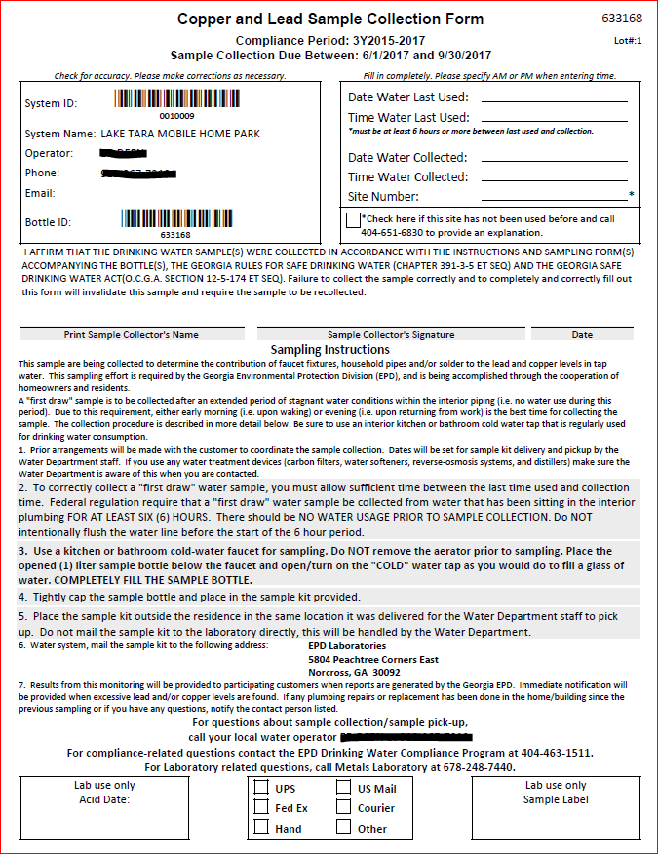
Example of Ga EPD Lab lead/copper results report showing the language/information needed for the required “Consumer Notice”:

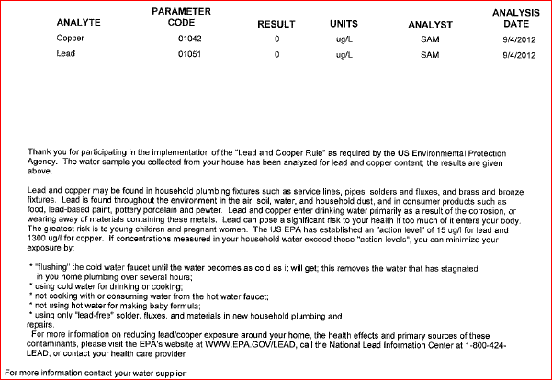

ATTENTION: REPORTING REQUIREMENT!!!!

Federal and State drinking water regulations for Lead and Copper require that water systems provide the customers with a ‘consumer notice’ that includes the lab results for the samples collected at their home/facility.

For each of the sampling sites used for Lead/Copper monitoring, within 30 days from when you receive all of your lead/copper sample results from the lab, you must provide a copy of the official lead/copper lab results report(s) to the customers served by that sampling site. Failure to provide this information to these customers will constitute a State and Federal violation!

Please complete this ‘Consumer Notice Certification’ form to verify and certify that you met this requirement and that the participating homeowners were given copies of their official lab results reports for their individual home’s sample. The official lab reports contain not only the actual sample results but also required additional information/language that the customers must receive.

For non-transient/non-community water systems, you can meet this requirement by posting in a visible common area copies of the lead/copper results reports for all samples collected at that facility after each lead/copper sampling event.

Thank You for your efforts in achieving and maintaining compliance with the Safe Drinking Water Rules and Regulations!
Lead & Copper Consumer Notice Certification Form
Water System ID#: __ __ __ __ __ __ __ Water System Name: ______________________________

Contact Person: _________________________________ Phone :(____) ______________________

Monitoring period to which the notice applies (for example, June–Sept. 2015):________________________

Copies of official lab results reports were provided to all customers who participated in this sampling event by: (Date) _____/______/______

DELIVERY METHOD
The copies of the lab results reports were distributed by the following method, check all that apply:

By Direct Mail______ By Hand Delivery_____ By Electronic mail_____

Other (e.g. posting, only applicable for non-community type water systems, results for all samples taken at that building/facility should be posted) ________

Signature of Owner, Administrative Contact, or Official Custodian

I, ___________________________________, hereby certify that the lead & copper consumer notice/official lab results reports have been provided to the consumers served by each sampling site that was used for this sampling event.

Signature_______________________________________ Date _____/_______/______

Please email, fax, or mail this completed form to:
GA EPD-Drinking Water Program-Compliance Unit (Attn: Tamara Frank or Amina Wofford)
2 MLK Jr. Dr., Floyd Towers-East 1152, Atlanta GA 30334

Email Address: tamara.frank@dnr.ga.gov amina.wofford@dnr.ga.gov
Office FAX #:404-656-2453 Office phone#: 404-463-1511

