Boil Water Advisory Guidance Manual



Georgia Environmental Protection Division Watershed Protection Branch
January 2026

Boil Water Advisory Guidance Manual

Commonly Used Abbreviations and Acronyms

AWWA | American Water Works Association
AWWA C651-14 | AWWA Standard for Disinfecting Water Mains
BWA | Boil Water Advisory
EPD | Georgia Environmental Protection Division
PWS | Public Water System
SDWA | Safe Drinking Water Act
USEPA | United States Environmental Protection Agency

Useful links and References:

Georgia Environmental Protection Division
All reporting forms referenced in this document are available here: https://epd.georgia.gov/forms-permits/watershed-protection-branch-forms-permits

The Federal Safe Drinking Water Act Public Notification Rule
  - Basic Information: https://www.epa.gov/dwreginfo/public-notification-rule
  - Full text: https://www.ecfr.gov/current/title-40/chapter-I/subchapter-D/part-141/subpart-Q
  - Handbook: https://www.epa.gov/system/files/documents/2023-05/CWS_NTNC%20PN%20Handbook_508_March%202023.pdf

The American Water Works Association
  - http://www.awwa.org/
  - To purchase a copy of AWWA C651-14: https://store.awwa.org/AWWA-C651-14-Disinfecting-Water-Mains-PDF

Boil Water Advisory Guidance Manual

Table of Contents

INTRODUCTION 1
SECTION I 3
WHEN TO ISSUE A BOIL WATER ADVISORY 3
  - INCIDENCES THAT MAY NECESSITATE A BOIL WATER ADVISORY 3
  - INCIDENCES THAT REQUIRE TIER 1 PUBLIC NOTICE 3
  - PROTOCOLS FOR DETERMINING TYPE OF WATER MAIN BREAK (WMB) 4
SECTION II 7
ISSUING A BOIL WATER ADVISORY 7
  - PUBLIC NOTIFICATION PROCEDURES 7
  - TEMPLATE FOR BOIL WATER ADVISORY 8
SECTION III 9
DISINFECTION PROCEDURES 9
SECTION IV 10
WATER QUALITY TESTING 10
SECTION V 11
LIFTING A BOIL WATER ADVISORY 11

INTRODUCTION

Recognizing that water distribution system pipe breaks, or are
Water Main Breaks (WMB),
common emergencies encountered by water systems, the Watershed Protection Branch of the Environmental Protection Division (EPD) has developed this guidance document to:

- Define types of WMBs;
- Clarify when to notify EPD;
- Clarify when a Boil Water Advisory (BWA) should be issued;
- Explain the regulatory expectations regarding a sanitary repair;
- Define sampling procedures that are acceptable to the EPD to assure potable drinking water quality following completion of the sanitary repair; and
- Assist in determining when to lift a BWA.

During a WMB, it is of foremost importance to minimize the disruption of water supply in order to protect public health by maintaining a water supply sufficient for potable use. In this regard, water distribution mains should be equipped with a sufficient number of valves to minimize service interruption during repairs. In addition, valves should be periodically exercised to ensure operability.

Water outages, as well as low water pressure, interfere with typical potable water uses (e.g. drinking, cooking, food preparation), and maintenance of sanitary conditions (e.g. bathing, hand washing, toilet flushing) within the home or business. In addition, the loss of positive pressure within a potable water pipe may allow disease-causing microorganisms from surrounding soil or groundwater to be drawn into the pipe, and thus into contact with the potable water due to pressure differences. Lastly, during the process of repair, contamination of potable water may occur if the interior surface of the pipe has come into direct contact with groundwater or soil.

To address these sanitary concerns, upon the completion of construction (including repairs) all surfaces that come in contact with potable water shall be disinfected in accordance with the American Water Works Association Standard for Disinfecting Water Mains – AWWA C651-14, as amended and supplemented.

While WMBs are unplanned, EPD does not consider all WMBs to be reportable incidents. Section I of this guidance document provides clarification of which events trigger reporting requirements. Should a BWA be needed for a WMB, Section II describes how to issue the BWA to comply with State and Federal requirements. Section III describes disinfection procedures, Section IV describes water quality testing requirements, and Section V describes requirements for lifting the BWA.

This document generally applies to community water systems as the vast majority of non- community water systems do not have distribution systems for the delivery of drinking water and would not experience the types of incidents described herein. However, the guidance and materials presented may be used by non-community water systems as appropriate.

Any uncertainty regarding these guidelines and the applicability to a specific incident should be reviewed with staff from Georgia Environmental Protection Division (EPD) in a timely manner (within three (3) hours of occurrence) by Contacting the assigned EPD Drinking Water Program inspector, compliance officer or engineer. Discuss the situation with EPD for actions to be undertaken. On nights and weekends, contact the EPD using the Emergency Call number of (404) 635-7200. Contact the local county health department as well as the county Emergency Management office (EMA) to apprise them of the situation.

Please note that the requirements presented in this guidance document apply only to water main breaks, loss of pressure, loss of water and loss of power that would in turn result in issuing a “Precautionary Boil Water Advisory”. If a Water System has an incident that triggers a Tier 1 Boil Water Notice, such as an MCL violation under the Surface Water Treatment Rule, Ground Water Rule, Revised Total Coliform Rule, or any other compliance and enforcement issue, such as a Consent Order requirement, then they should refer to the EPA Public Notification Rule for Templates or consult with EPD for assistance.

SECTION I

When to Issue a Boil Water Advisory

Incidences that may necessitate a Boil Water Advisory
A Boil Water Advisory may be necessary for any of the following incidences:

    - When a wide-spread loss of positive pressure occurs in the distribution system due to a power outage, pump failure or other system malfunction. When system wide pressure or pressure over a large extent of the distribution system falls below 20 PSI, loss of positive pressure has deemed to occur.

    - For water main break or leaks, refer to Table 1 and Figure 1 for guidance on when a BWA is necessary. In these circumstances, positive pressure is considered to be anything greater than zero.

    - Failure to maintain a detectable residual of free chlorine in all parts of the distribution system. If the residual disinfectant concentration is measured by approved analytical methods and not detected, the supplier may, upon approval by the Division, determine and report detectability by the use of heterotrophic plate count measurements as required by 40 CFR § 141.72 (1989) and other applicable paragraphs of 40 CFR Part 141.

    - Water systems are advised to contact critical use facilities such as schools, day care, assisted living facilities, nursing homes, dialysis center hospitals and other health care centers in the vicinity of a water main break when water pressures are significantly lower than normal.

Incidences that require Tier 1 Public Notice

A Tier 1 Public Notice is required to be issued for incidences including:

    - Presence of Escherichia coli (E.coli) in finished water

      - when confirmed by repeat sample;

      - upon first detection when any other information indicates water may be unsanitary. (e.g.
Flooding of well); or

      - upon failure to take all required repeat samples after an E. coli positive routine sample.
    - Presence of fecal indicators in raw groundwater at systems that do not provide 4-log treatment

    - Turbidity exceedances in finished water that pose an imminent threat to public health.

Please refer to the EPA Public Notification Rule for Templates and for situations other than those listed above that would require a Tier 1 Public Notice or consult with EPD for assistance.

Protocols for Determining Type of Water Main Break (WMB)
Upon discovery of a compromised water distribution system as identified above, perform an initial assessment to include location, service area affected, proximate source of problem, and remediation needed. For water main breaks and leaks, utilize Table 1 and the flow chart in Figure 1 on the following pages to determine the need for a BWA.

TABLE 1
DETERMINING TYPE OF WATER MAIN BREAKS AND ASSOCIATED RESPONSES

 | Identify Break/Leak Type | Type 1 | Type 2 | Type 3 | Type 4
 | Risk | Minimal | Minimal | Moderate | High
 | Pressure Maintained Throughout Water Loss | Yes - Repaired Under Pressure | Yes - Controlled Shutdown | Questionable - Localized Loss of Pressure | Not Likely - Widespread Loss of Pressure
 | Contamination Intrusion | No | No | Possible | Likely
 | Necessary Actions
First Considerations | Document Possible Contamination | No | No | Yes | Yes
First Considerations | Isolate Broken Pipe segment by shutting valves | No | Yes | TO EXTENT POSSIBLE | TO EXTENT POSSIBLE
First Considerations | Issue Boil Water Advisory Notice | No | No | TBD*  based on depressurization extent  and presence of contamination | Yes
Make Repair | Safely Excavate around and Below Break | Yes | Yes | Yes | Yes
Make Repair | Pump/Maintain Pit Water Level Below Break | Yes | Yes | Yes | Yes
Make Repair | Disinfect Repair Parts with bleach | Yes | Yes | Yes | Yes
Make Repair | Make Repair | Yes | Yes | Yes | Yes
Following Repair | Flush & Disinfect per AWWA C651-14 | No | Yes | Yes | Yes
Following Repair | Check for Adequate Residual disinfectant level | Yes | Yes | Yes | Yes
Following Repair | Conduct Bacteriological Sampling | No | No | TBD*  based on depressurization extent  and presence of contamination | Yes
Following Repair | Instruct Customers to Flush premise plumbing upon return to service | No | Yes | Yes | Yes

*If the loss of positive pressure is limited to the pipe, section, or area flushed or disinfected, then not necessary. However, if the area of depressurization is larger than the treated area, then BWA should be issued as precautionary.

FIGURE 1
BOIL WATER ADVISORY ISSUANCE DECISION FLOWCHART FOR WATER MAIN BREAK

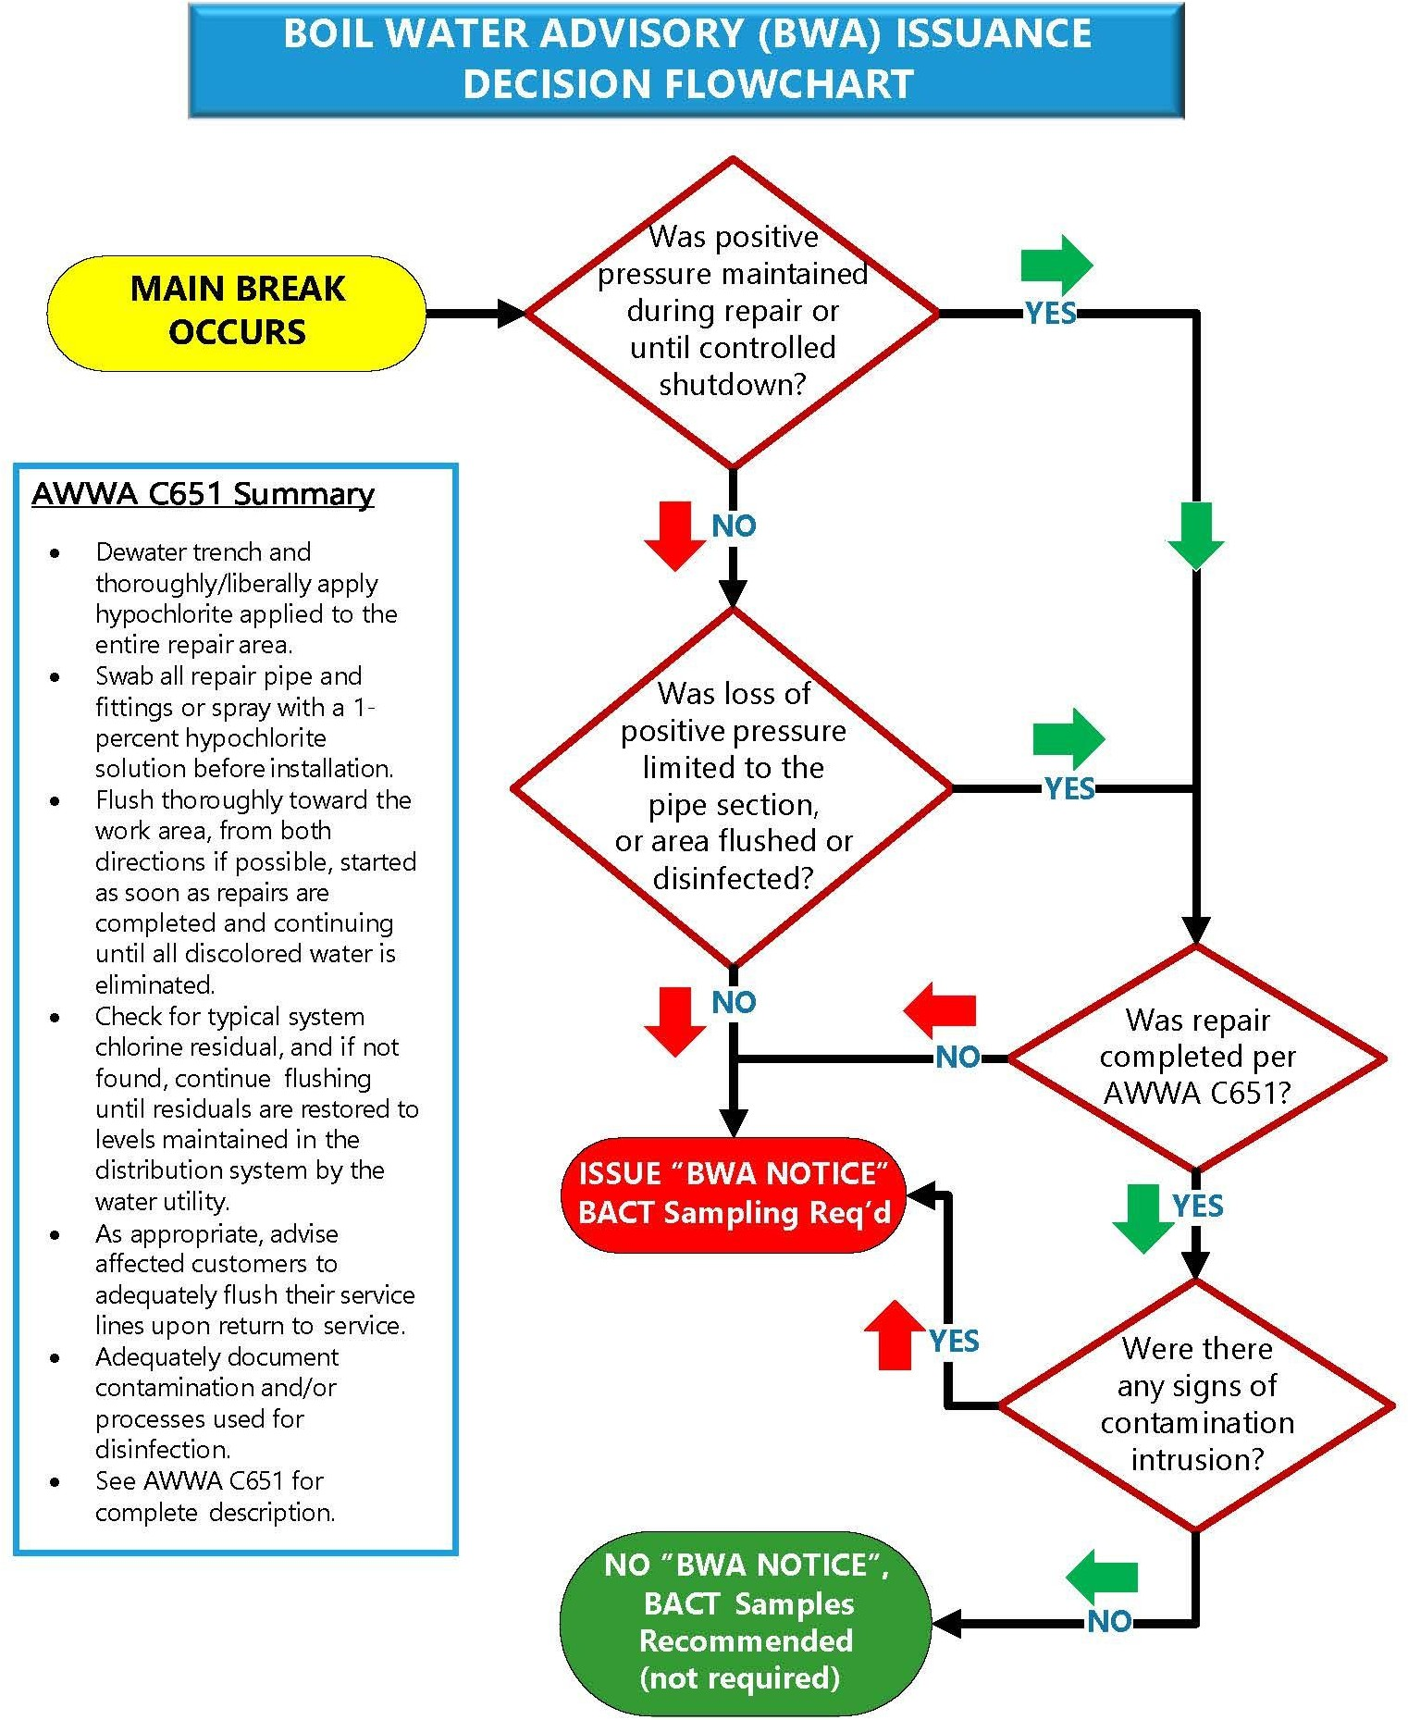

SECTION II

Issuing a Boil Water Advisory

After following the protocol and flowchart in Section 1 if it is determined that a Boil Water Advisory is necessary for the water main break or occurrence of any other incidences identified in Section 1 then the following steps must be taken:

- Contact the assigned Georgia Environmental Protection Division’s (EPD) Drinking Water Program inspector, compliance officer or engineer. Discuss the situation with EPD for actions to be undertaken. On nights and weekends, contact the EPD using the Emergency Call number of (404) 635-7200. Contact the local county health department as well as the county Emergency Management office (EMA) to apprise them of the situation.

- Issue a public advisory targeted to the affected customers.

Public Notification Procedures
Issue a Boil Water advisory to the affected customers using the template below. Please take the necessary steps to issue this notice using as many communication methods as possible which could include the following:

- Radio & television announcements
- Publishing in local and regional newspaper
- Reverse-911 calls
- Hand delivery
- Other appropriate methods

The goal is to ensure that affected water customers have been notified of this public advisory.

Template for Boil Water Advisory
The following template shall be used for publishing and posting of boil water advisory

Public Notification
BOIL WATER ADVISORY

The [County, City, Water System] is issuing this advisory due to [Indicate the cause for the service interruption in the system here – for example, the repair of a water main leak, the loss of power and/or pressure] which may be disrupting your water supply or causing water pressure in parts of the water system to drop to very low levels. The advisory is being issued out of an abundance of caution – there is the potential a health hazard may exist due to microbial contamination in these areas without positive pressure.

In order to protect the public from a potential health hazard, customers that have experienced water outages and/or low water pressures are advised to use only boiled tap water or bottled water for drinking, cooking, or preparing food. To properly boil tap water for use, customers should:
- Heat water until bubbles come quickly from the bottom of the container;
- Continue heating the water for one minute once it begins to boil;
- Remove the water from the heat source and allow to cool before use.

During a Boil Water Advisory, the Centers for Disease Control (CDC) recommends that boiled tap water or bottled water be used for following:
- Drinking
- Brushing teeth
- Washing food and preparing food and baby formula
- Making ice
- Drinking water for pets
Other activities such as cloth washing, dish washing and other uses can be done without boiling tap water, if done properly. The complete CDC guidance can be found at this website: https://www.cdc.gov/water-emergency/about/drinking-water-advisories-an-overview.html
The advisory is in effect until [County, City, Water System] has done the appropriate testing to be confident that there is no longer a public health concern. Customers will be notified immediately when the Advisory is lifted. Once the Advisory is lifted you should flush all faucets for a minimum of two minutes before using for drinking or food preparation.

[Indicate the name of Public Water System and a contact telephone number for questions.]

SECTION III

Disinfection Procedures

Any water main shut down and depressurized during repair may allow contamination to enter the potable water distribution system by cross-connection contamination, groundwater seepage, animals, dirt, etc. Appropriate procedures for the sanitary repair, disinfection and flushing of the water main must be followed in accordance with the American Water Works Association Standard for Disinfecting Water Mains – AWWA C651-14, as amended and supplemented.

Water main leaks or breaks repaired in-service with clamping devices (or other devices), while the water main remains pressurized, present little danger of contamination and do not require disinfection.

De-chlorination of highly chlorinated waters is required prior to the discharge to either sanitary or storm sewers or any surface or groundwater.

SECTION IV

Water Quality Testing

When a Boil Water Advisory is in effect, water quality testing is an essential component of the sanitary repair and must be performed to demonstrate that the integrity within the distribution system has been restored. Free chlorine residual measurements and coliform bacteria samples must be collected from enough sites to adequately represent all areas of the distribution system.

The number of required samples is dependent on the number of connections affected by the BWA (see Table below).

Number of connections affected by the BWA* | Minimum Number of Samples
15 – 1,000 | 3
1,001 – 2,500 | 5
2,501 – 5,000 | 10
5,001 – 10,000 | 12
10,001 – 25,000 | 15
25,001 – 50,000 | 18
50,001 – 100,000 | 20
>100,000 | As recommended by EPD

For BWAs that affect less than 15 connections, at least one sample should be collected downstream of the repair, or one sample from each end of the repaired break if flow direction is uncertain/unknown (consistent with AWWA C651-14). Chlorine residuals must be analyzed at the same locations in the distribution system where samples were drawn from.

SECTION V

Lifting a Boil Water Advisory

Unless issued under an EPD Order or issued per the Public Notification Rule, an affected water system may rescind a Boil Water Advisory (wholly or in-Part) without EPD approval as long as the following conditions are met. However, the PWS should notify EPD as soon as possible that the advisory has been lifted and submit test results from microbiological testing.

    - Complete appropriate repairs or mitigation - Distribution system integrity must be restored by repairing and/or isolating all main breaks or successfully mitigating other problems that may have created a loss of positive pressure. Pipes should be flushed until the water is clear. Adequate water should be pumped into the distribution system to pressurize all areas and build adequate reserve in the storage tanks.

    - Normal operating conditions have resumed, such as the discontinuation of the provision of alternate water supplies, discontinuation of the use of emergency interconnections, hydrant-to-hydrant connections, or bulk water delivery, etc.

    - All microbiological tests (performed by a certified laboratory) must be negative for total coliform bacteria. A copy of the laboratory results must be sent to EPD.

    - Water quality samples show a minimum chlorine residual of 0.2 mg/L throughout the distribution system.

    - Water system shall keep a record of all water main breaks and boil water advisories issued. These records shall be available for inspection when requested by EPD.

