February 2019 Climate Summary – Georgia
Lauren Holt, Service Climatologist
State of Georgia Climate Office
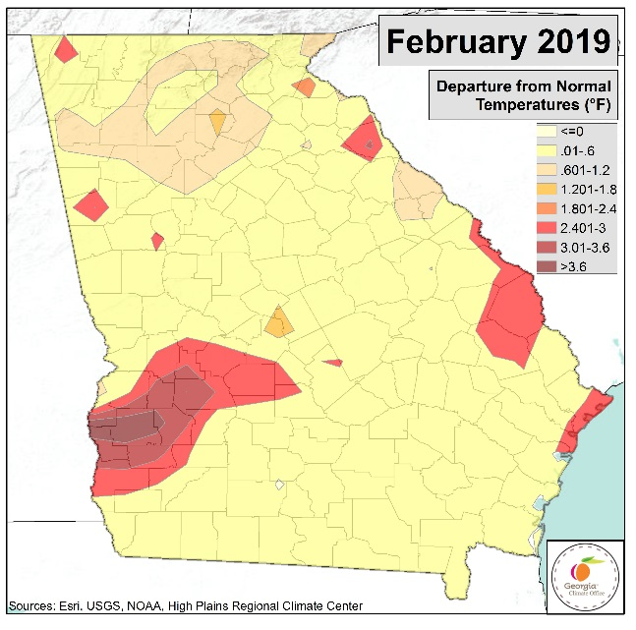
February in Georgia was characterized by above normal temperatures statewide that led to record warmth and several days with high temperature records broken. A stark gradient in precipitation is noted. Far north Georgia received much above normal precipitation while central and southern Georgia recorded below normal rainfall. Meteorological winter runs from December through February and proved to be warmer and wetter than normal. An active weather pattern persisted, and four tornadoes occurred during February. However, since the majority of rain fell in north Georgia, south Georgia reported abnormally dry conditions by the end of the month.
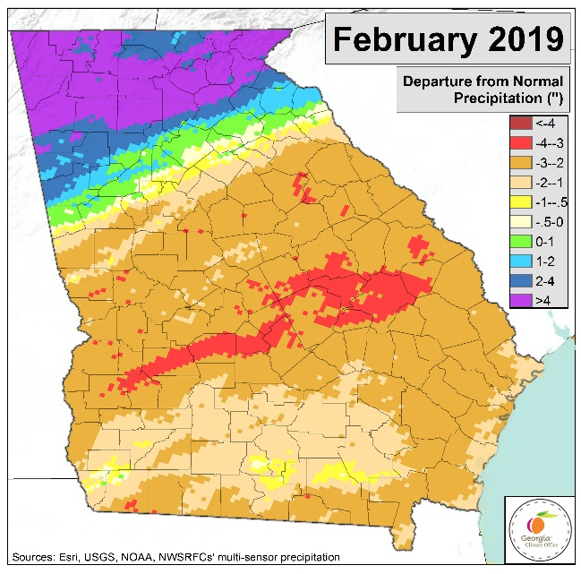
Atlanta’s average February temperature was 53.8°F (+6.6°) and ranked as 7th warmest on record. Both Athens and Macon had their 9th warmest February on record with 52.2° (+5.0°) and 55.8° (+5.8°), respectively. Columbus recorded 58.7° (+7.6°) and had its 5th warmest February, Savannah recorded 60.4° (+7.4°) and ranked as 7th warmest on record, and Augusta’s monthly average temperature was 55.8° (+6.7°) and ranked as 12th warmest February on record. The average temperature for the entire state of Georgia was 56.0° (+7.4°), ranking as 4th warmest on record. The record-breaking heat caused numerous daily high temperature records to be broken as evident in table 1 below. The station with the highest monthly mean average temperature was the BRUNSWICK COOP in Glynn county with 62.6°. The Rabun County GERMANY VALLEY COOP station recorded the lowest monthly mean average temperature with 45.5°.
Savannah was the driest of all the major climate sites with only 0.89” (-1.90”) which ranked as 11th driest February on record. Augusta’s total monthly precipitation was 1.14” (-2.78”) and ranked 11th driest on record, Columbus recorded 1.50” (-2.94”) and ranked as 9th driest, Macon’s monthly precipitation totaled 1.37” (-2.99”) and ranked as 7th driest, Athens recorded 3.61” (-0.87”), and Atlanta’s total precipitation was 4.14” (-0.53”). The statewide average precipitation was 3.24” (-1.27”). In Lumpkin, White, and Rabun counties, three stations (DALONEGA 6.4 NW CoCoRaHS, SAUTEE 3W COOP, and DILLARD 0.7NNW CoCoRaHS) recorded over 13” of precipitation with 13.73”, 13.22”, and 13.21”, respectively. Many other sites in north Georgia also recorded over 10” of rainfall during the month. A few sites in extreme northeast Georgia recorded trace amounts of snow throughout February, but there were no significant accumulations reported.
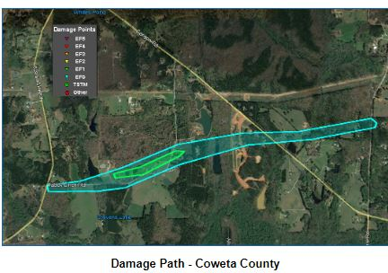
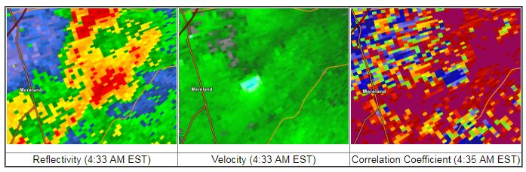
As a strong low pressure system pushed through the state on February 12th, four EF-0 tornados formed in Fayette, Clayton, Henry, and Macon counties from quasi-linear convective systems. Minor damage was reported in their short paths, but additional straight-line wind damage occurred elsewhere in the state as storms swept the area. Another severe weather event in Moreland in Coweta county on February 24th caused an EF-1 tornado. Numerous trees were uprooted, and several homes saw roof damage with one metal roof blown completely off.
Damage path and radar images from the Coweta county tornado on February 24th.
The United States Drought Monitor showed that Georgia was drought-free throughout February until the last week of the month when a very small area of D0 was introduced into east-central Georgia.
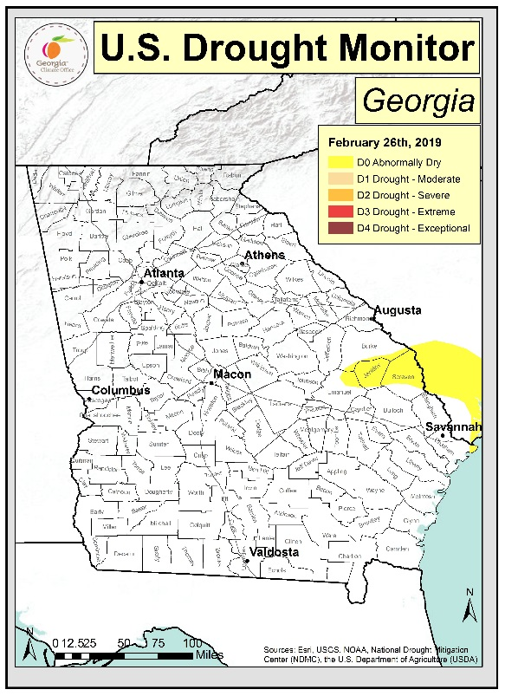
Meteorological winter ended on February 28th. Temperatures across the state were much above normal. Precipitation was much above normal in north Georgia, and slightly above to near normal in much of south Georgia. The statewide average winter temperature was 51.4° and the average precipitation was 17.62” (+4.64”). Table 2 shows temperatures, precipitation, and rankings for major climate sites in Georgia during meteorological winter.
According to the Climate Prediction Center, El Niño conditions are present and there is currently an El Niño Advisory. Equatorial sea surface temperatures are above average across most of the Pacific Ocean. Weak El Niño conditions are likely to continue through the Northern Hemisphere spring 2019 with about an 80% chance and into summer with about a 60% chance. The CPC’s three-month seasonal outlook shows chances for above normal temperatures statewide. There are also chances for above normal precipitation statewide, with a higher chance of above normal rainfall in the southern half of the state.
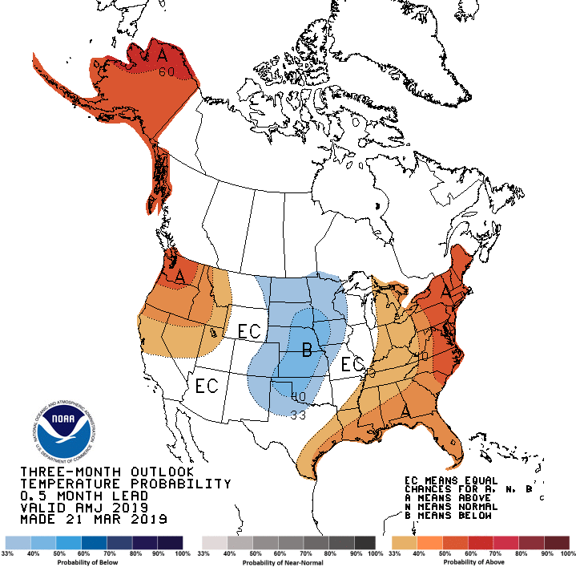
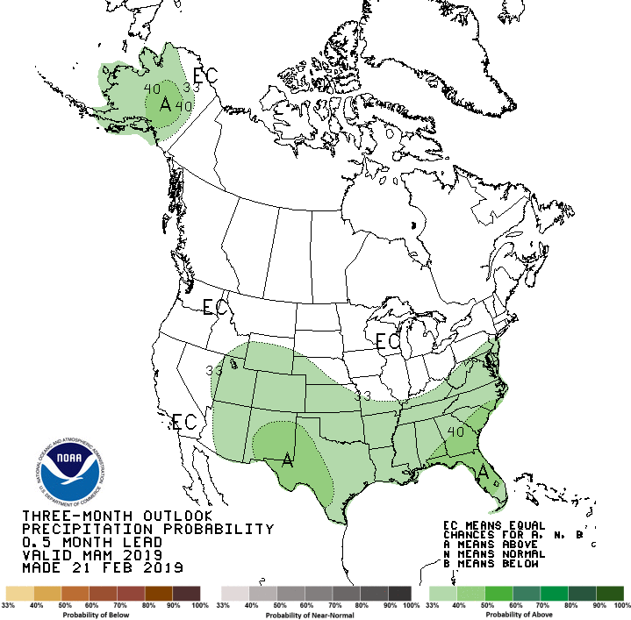

Table 1:
Daily High Temperature Records – February 2019
City | Date | Record | Temperature | Previous Record
Augusta | 2/5 | Maximum | 81° | 2008 (tie)
Atlanta | 2/6 | Minimum | 59° | 57° set in 1927
Augusta | 2/6 | Maximum | 80° | 1927 (tie)
Atlanta | 2/7 | Minimum | 62° | 1884 (tie)
Atlanta | 2/7 | Maximum | 80° | 72° set in 1937
Athens | 2/7 | Minimum | 62° | 56° set in 1927
Athens | 2/7 | Maximum | 81° | 76° set in 1927
Macon | 2/7 | Maximum | 81° | 79° set in 1999
Columbus | 2/7 | Maximum | 82° | 1927 (tie)
Augusta | 2/7 | Maximum | 85° | 80° set in 2017
Savannah | 2/7 | Maximum | 82° | 2018 (tie)
Augusta | 2/12 | Maximum | 82° | 79° set in 2017
Macon | 2/22 | Maximum | 83° | 1962 (tie)
Savannah | 2/22 | Maximum | 86° | 83° set in 2018

Table 2:
Meteorological Winter – December 2018 through February 2019
City | Average Temperature | Ranking | Total Precipitation | Ranking
Atlanta | 49.4° | 10th warmest | 22.20” | 8th wettest
Athens | 48.2° | 15th warmest | 19.84” | 7th wettest
Macon | 51.8° | 12th warmest | 13.78” | 46th wettest
Columbus | 53.4° | 11th warmest | 15.08” | 40th wettest
Augusta | 51.9° | 13th warmest | 11.48” | 64th wettest
Savannah | 55.8° | 16th warmest | 11.58” | 32nd wettest

