Industrial Stormwater
Georgia EPD Online System (GEOS) Guide

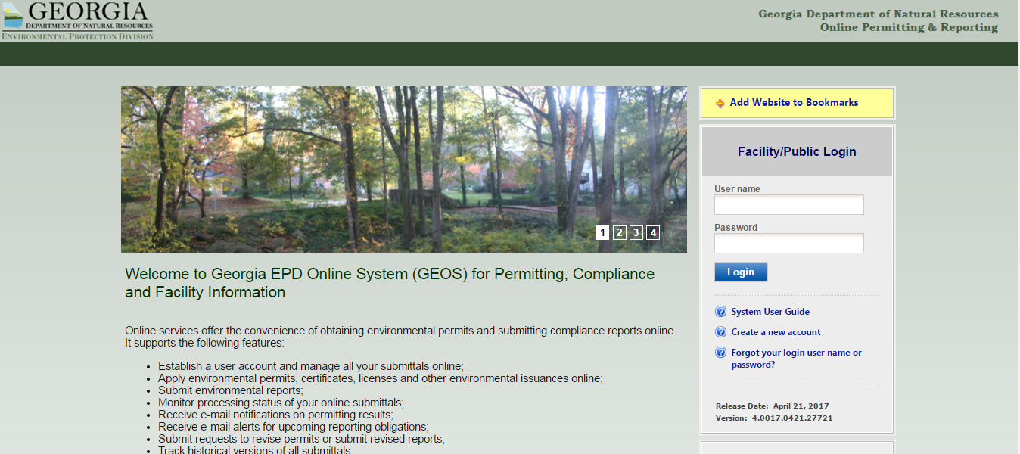

TABLE OF CONTENTS

- Creating the Account as a Responsible Official (RO)

- Creating the Account as a Preparer

- Adding a Preparer

- Renewing the NOI

- Submitting an Annual Report

- Contact Information

- CREATING THE ACCOUNT AS A RESPONIBLE OFFICAL (RO)

- Go to this website:
https://geos.epd.georgia.gov/GA/GEOS/Public/GovEnt/Shared/Pages/Main/Login.aspx

- Select “Create an Account” on the right side of the website.

- Select “RO/Owner for Stormwater Industrial,” and then select “Associate Facility” to find your facility.

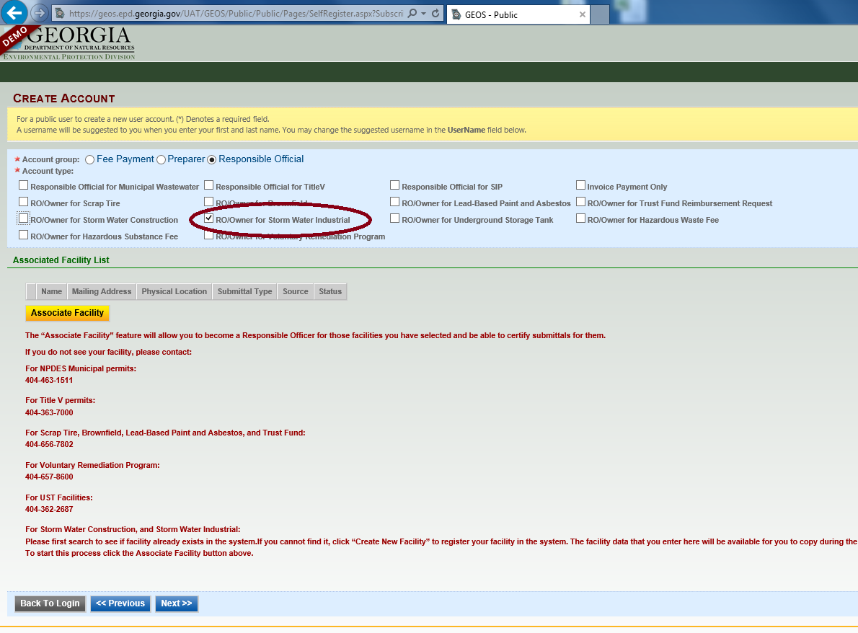

- When searching for your facility, entering a partial address OR facility, and not the full address or facility, will improve the chances of finding your facility.

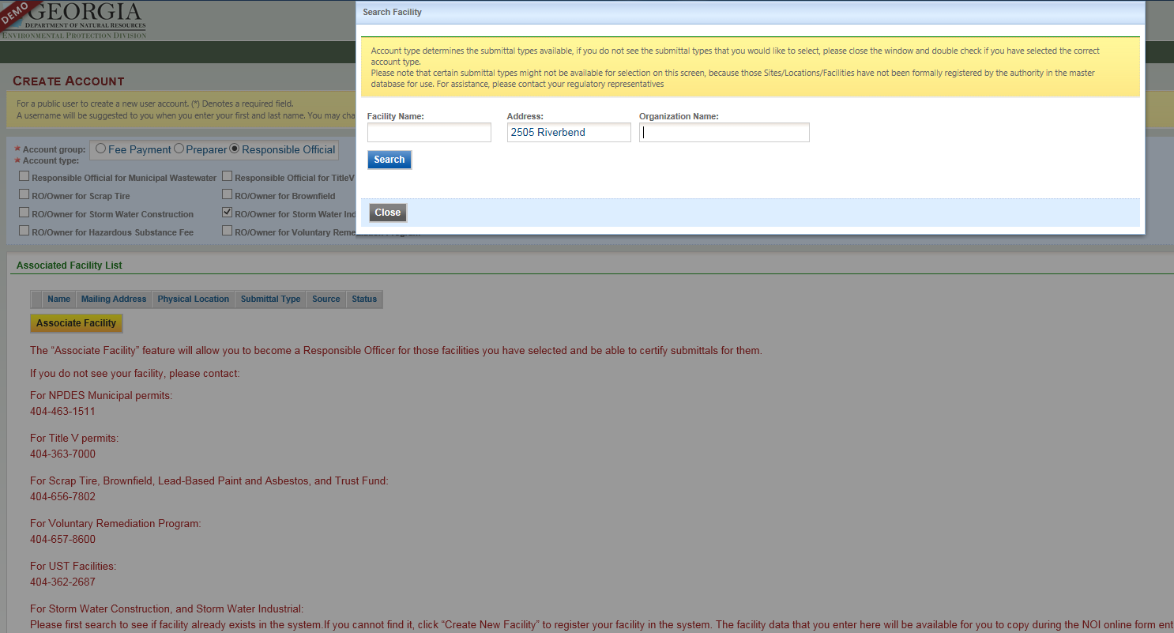

- Once the facility is found, confirm in the “Source” column that your facility has “NPDES-SWI” indicating the facility has access to the industrial stormwater forms. Select the checkbox in the first column for your facility and select the checkbox for “Industrial Stormwater (GAR050000) Annual Report” and “Industrial Stormwater (GAR050000) NOI/NEE.” If “NPDES-SWI” is not shown for your facility, contact EPD to update your facility.

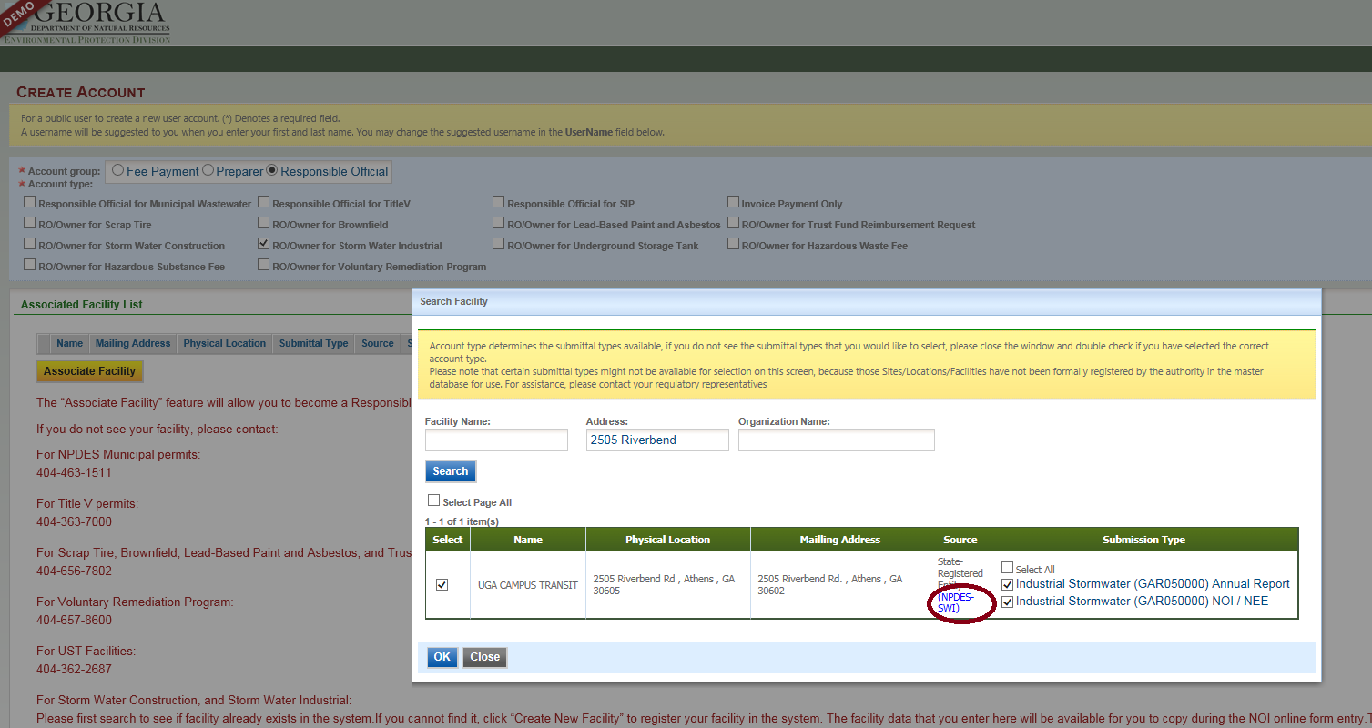

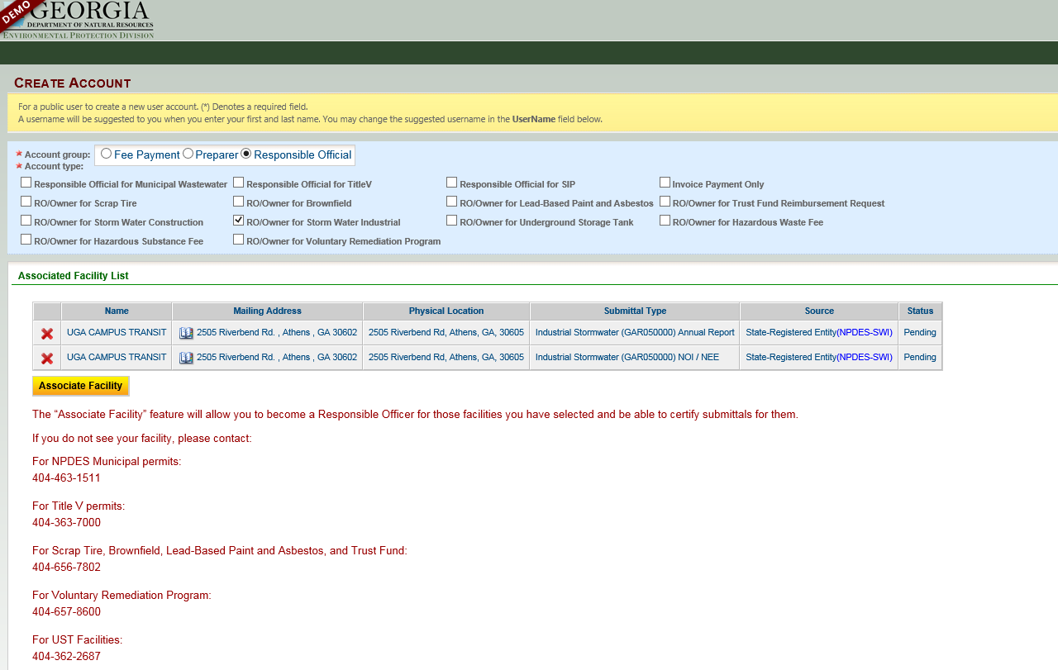

- NOTE: REMEMBER your security questions. When submitting annual reports and NOI/NEE, you will be prompted for your security question and PIN number.

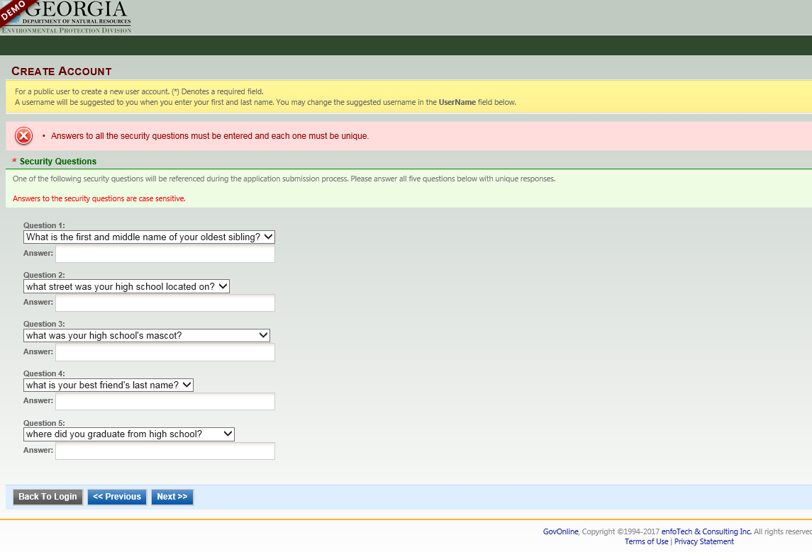

- You will have two options for proof of RO: 1) E-verify and 2) Electronic Subscriber Agreement (ESA). If you are submitting an ESA, you will have to complete the form for each facility and mail them, using certified mail, to EPD. Once the ESA is processed, the facility will be activated and linked to your account.

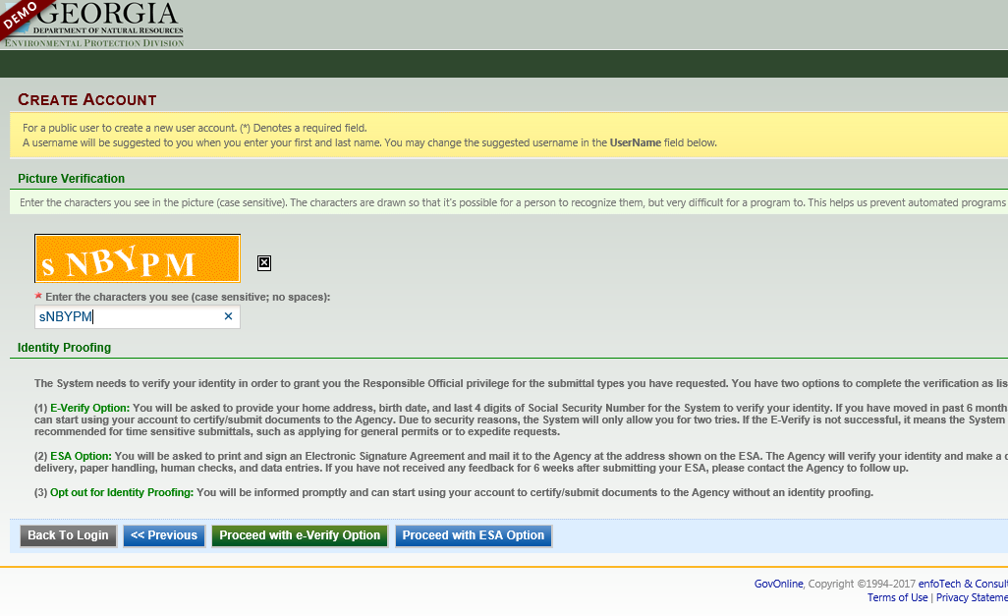
- Once your account has been created, you will receive an email with a temporary password. When you log into your account, create a new password and a PIN. SELECT “Save” when completed or the page will reset. NOTE: REMEMBER your PIN. You will need your PIN number each time you submit an annual report or NOI/NEE.

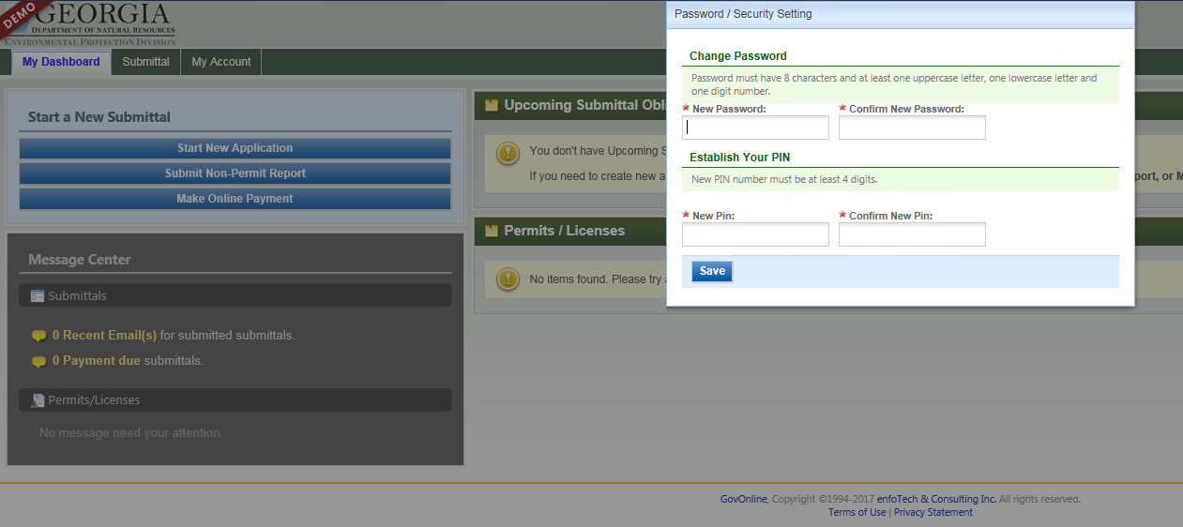

- CREATING AN ACCOUNT AS A PREPARER

- To create a Preparer account, select “Preparer” for the Account Group, and then select the “Preparer” box.
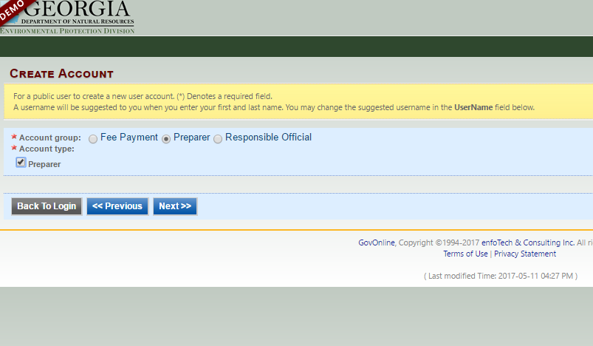

- Go to “My Account” and the “Associated RO” tab to confirm you are authorized by the RO. The RO can only authorize a preparer when the facility is approved. The RO finds and authorizes the preparer by their email.

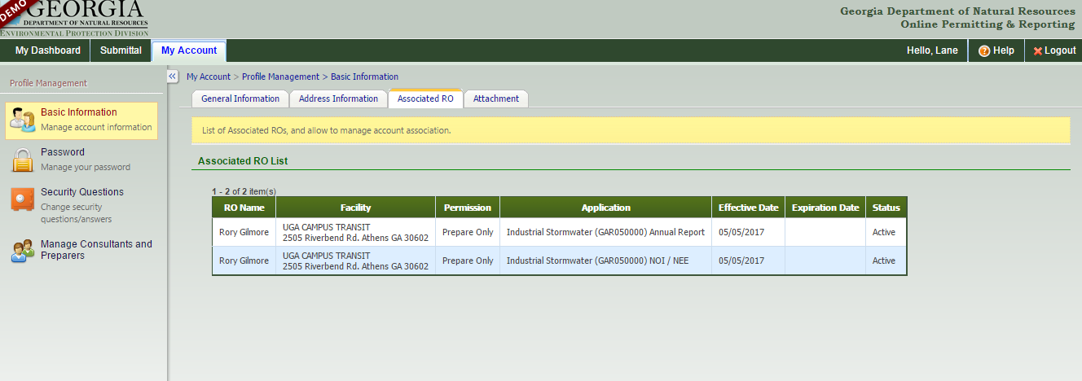

- ADDING A PREPARER

- Before authorizing a preparer for your facility, the preparer needs to create a GEOS account.

- The RO will go to “My Account” and select “Manage Consultants and Preparers.” Select “Add User” and then enter the email address that the preparer uses for their account.

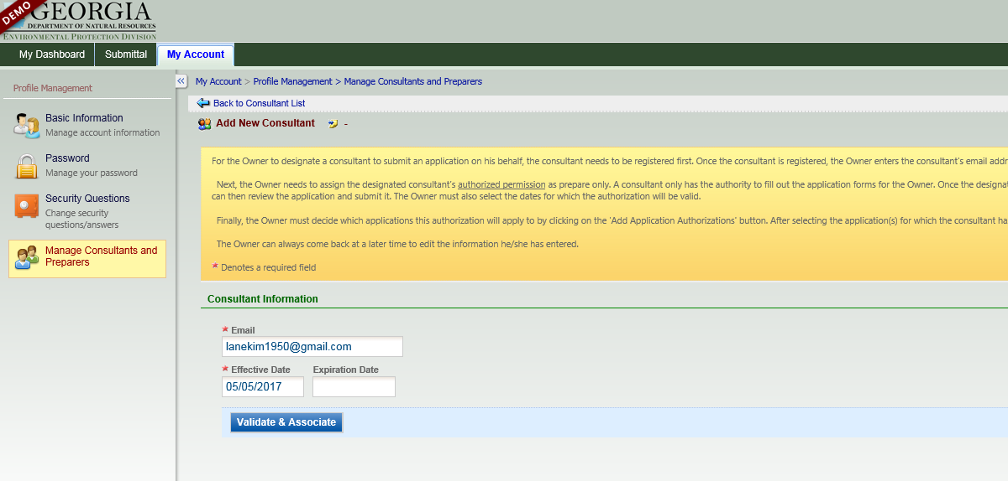

- Select the forms that the preparer can access.

- RENEWING THE NOI

- Once your facility is activated and linked to your account, you can see the permit on the main account page (Dashboard).

- Select “Action” and then, select “Renewal.” Complete/Edit the NOI form and submit.

NOTE: The 2017 NOI will be available on June 1, 2017. Do not submit a renewal before June 1. The renewal for the 2017 Industrial General Permit needs to be done by June 30, 2017.

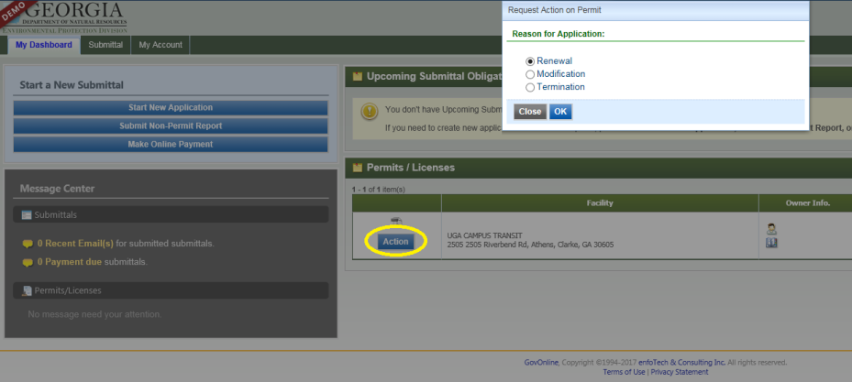

- SUBMITTING AN ANNUAL REPORT

- Select “Submittal” from the green bar at the top of the screen. Select “Start” for the Industrial Stormwater (GAR05000) Annual Report.

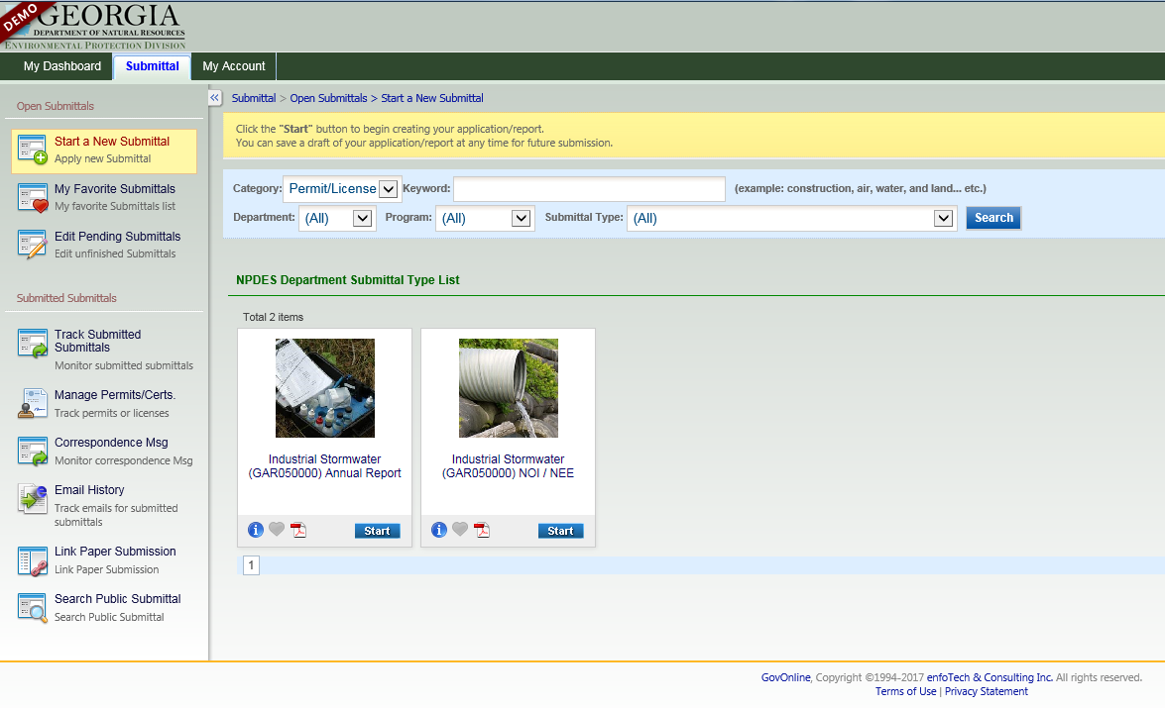

- Select the facility for which you wish to submit an annual report, and then select the “Get NOI/NEE Information” to autofill part of the form.

NOTE: If the “Effective NOI” box does not autofill when “Get NOI/NEE Information” is selected, contact EPD to resolve the issue.

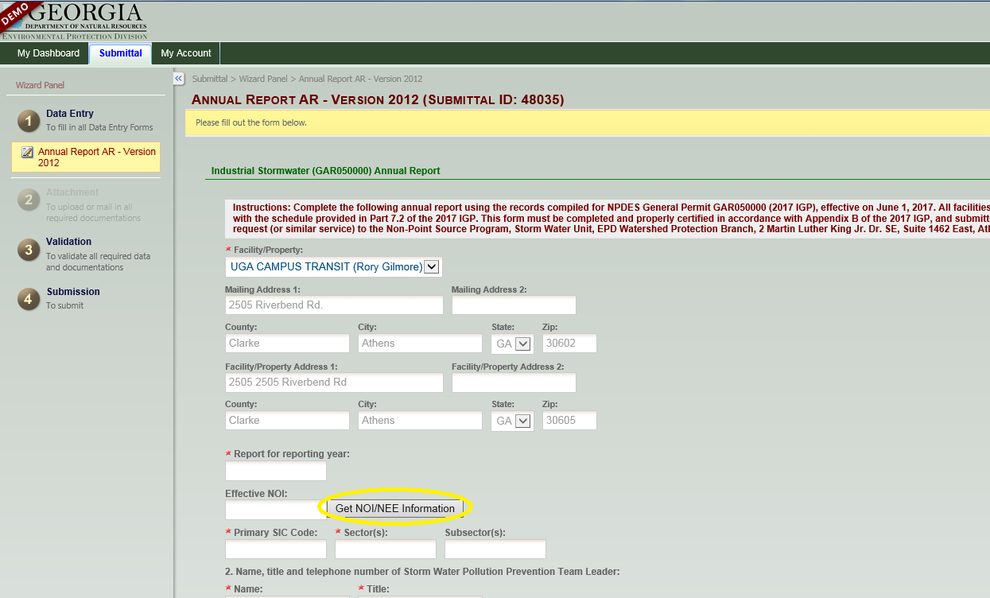

- To submit sampling results, use the provided Excel file. This Excel file can also be found on the Georgia EPD Industrial Stormwater website (http://epd.georgia.gov/npdes-industrial-storm-water-general-permits). On the next section of the annual report, upload the Excel file.

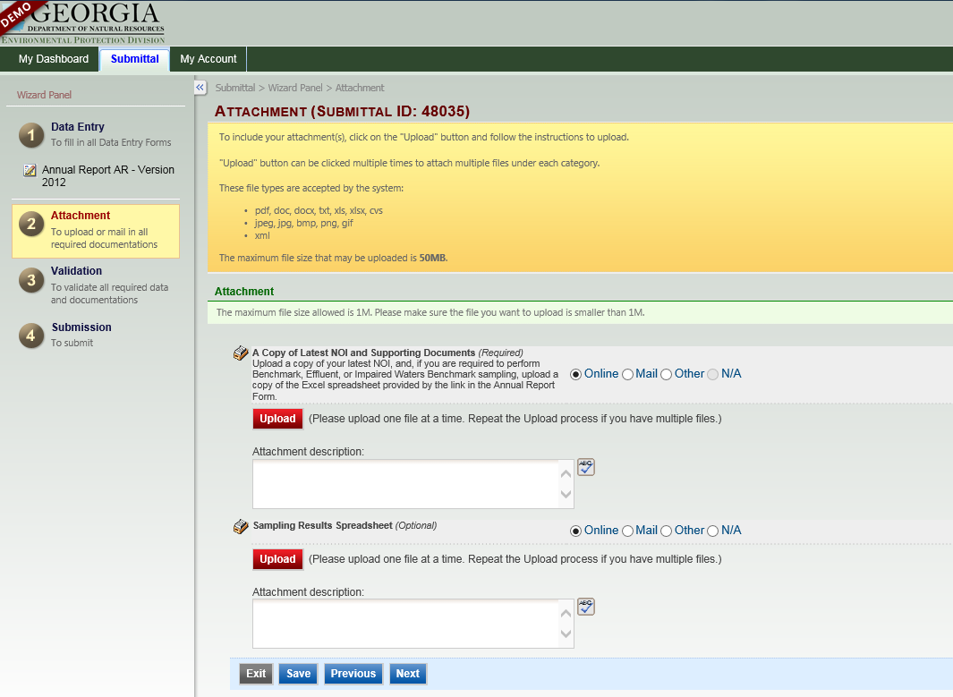

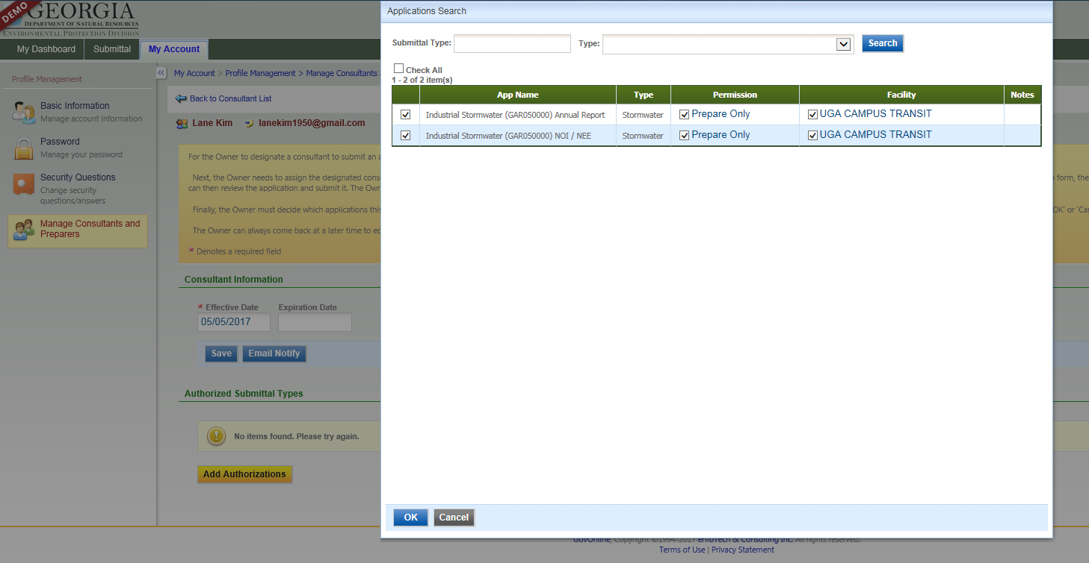

- CONTACT INFORMATION

For help with GEOS and the Industrial General Permit, please contact:

Anna Truszczynski
Stormwater Unit Manager
404.651.8548
Anna.truszczynski@dnr.ga.gov

Dan Loudermilk
Environmental Engineer
404.651.8542
Dan.loudermilk@dnr.ga.gov

Grey Won
Environmental Compliance Specialist
404.651.8541
Grey.won@dnr.ga.gov

