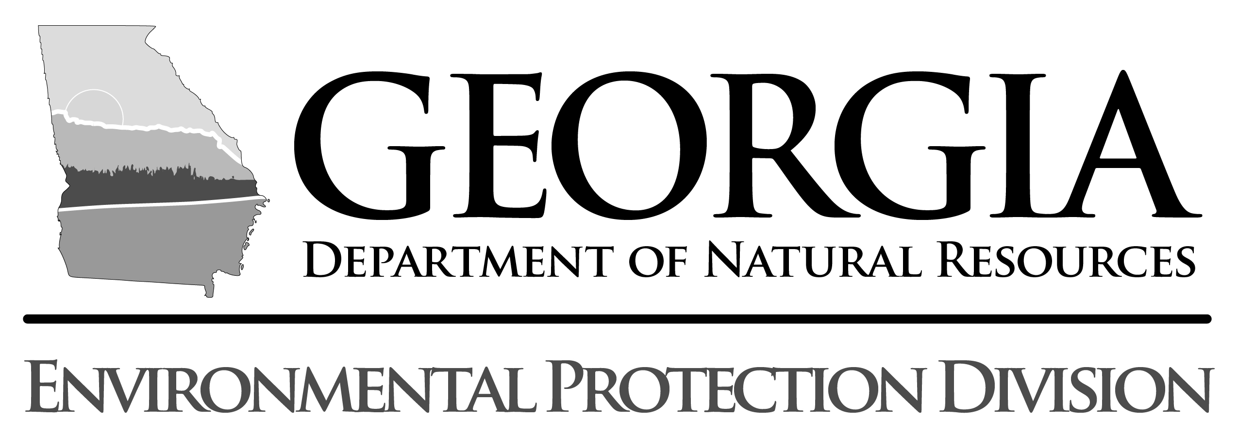

Important Information Regarding General NPDES Permit Nos. GAR100001, GAR 100002 and GAR100003:
Electronic Forms for Existing Construction Sites Will be Accepted Until December 15, 2018

WHO?: Existing PERMITTEES who did not file a Notice of Termination of coverage under the 2013 National Pollutant Discharge Elimination System (NPDES) General Permits for Discharges of Stormwater from Construction Activities before August 1, 2018, must Renew their coverage.

WHY?: The Georgia Environmental Protection Division (EPD) reissued General NPDES Permits Nos. GAR100001, GAR100002 and GAR100003 (Permits) on August 1, 2018, authorizing stormwater discharges from construction activities to the waters of the State of Georgia for a period of five years. All existing coverage under the 2013 NPDES permit expired on July 31, 2018. Coverage under the 2018 NPDES permits must be obtained through the mandatory electronic submittal of a renewal Notice of Intent (NOI) through the Georgia EPD Online System (GEOS) for electronic permit applications.

Under the Permits, all projects previously covered by the 2013 NPDES Construction Permit that did not reach final stabilization as defined in the Permit and/or did not file a Notice of Termination (NOT) must renew their NOI for continued coverage under the 2018 permit using this online system. The 90 day grace period to get this accomplished will end on October 30, 2018. However, due to unforeseen circumstances in initiating the new electronic submittal process, EPD will temporarily waive land disturbance fees and Erosion and Sedimentation Control Plan resubmittal for existing construction sites until December 15, 2018. Please continue to use the renewal form option on GEOS to allow for better EPD data tracking. The main EPD webpage for the GEOS system can be found at https://epd.georgia.gov/geos/. Specific guidance concerning Construction Stormwater is located here: https://epd.georgia.gov/geos/documents/construction-stormwater-instructions.

*Currently, All sites that fail to renew coverage before December 15, 2018 will have to apply for new coverage under the 2018 NPDES Permit. This will require the resubmittal of an updated Erosion and Sedimentation Control Plan and the repayment of Land Disturbance Fees.*

