
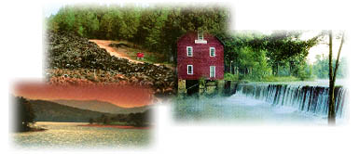

Application for a Permit to Use Groundwater

Part A – General System Information
(Part A must be accompanied by one copy of the Part B – Well Data form for each well in your system)
New Permit
Renewal | Please enter GW Withdrawal Permit No. -
Modify Existing GW Withdrawal Permit No. | Please enter GW Withdrawal Permit No. -
(Print or type ALL information)

Applicant Information
Contact Person: | Phone: |  | Email:
Contact Person: | Fax:
Company / Permittee:
Permittee Address:
(No. and Street) (City) (State) (Zip)
Water Use Name & Address (if different than above):

Permit For:
Monthly Average Withdrawal Limit requested: |  |  | Gallons Per Day (GPD)
Annual Average Withdrawal Limit requested: |  |  | Gallons Per Day (GPD)
For a beneficial use of |  | gallons of water per day, to be pumped from well(s)
Averaging hours pumping per day utilizing the |  |  |  | aquifer(s) for a
Consumptive use (Not returned to source) OR
Nonconsumptive use (Returned to source)

For…
Sanitary Facilities
Central Water Supply
Cooling Water
Process Water for
Other (please specify)

Location Map
County where well(s) is located:
All applications shall be accompanied by a map showing the location of the existing and proposed well(s); each well to be identified by number. The location map shall be the best map available, which may be a portion or a copy of a U.S. Geological Survey 7.5 min. quadrangle map, or latest county highway MAP, or city MAP, provided the submitted map is properly identified and should be no larger than 8½ x 11 inches.

And such other pertinent information submitted by the applicant or required by the Division.

Return Application To:
Georgia Environmental Protection Division
Water Supply Program

Groundwater Withdrawal Unit
2 Martin Luther King, Jr. Drive
Suite 1470A, East Tower

Atlanta, Georgia 30334
ground.water@dnr.ga.gov
Print or Type Name

Sign Name

Title

Date

