May 2016 Climate Summary – Georgia
Lauren Lindsey, Service Climatologist
State of Georgia Climate Office

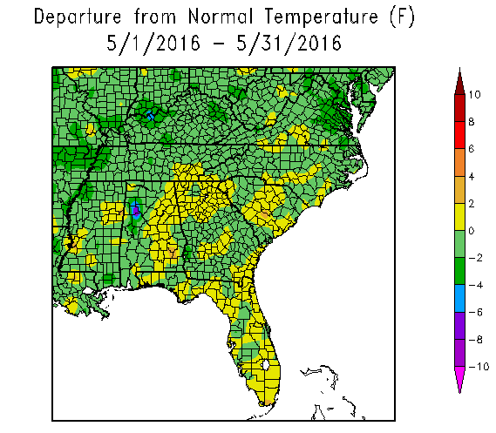
May in Georgia was characterized by variable temperatures across the state, but most locations stayed relatively close to normal. Precipitation was highly sporadic during the month. Areas in east-central and southeast Georgia saw well above normal rainfall, thanks in part to Tropical Storm Bonnie in late May plus abundant, surging gulf moisture in the middle of May. North Georgia generally saw below normal rainfall, while other areas were slightly below normal to normal in terms of precipitation.
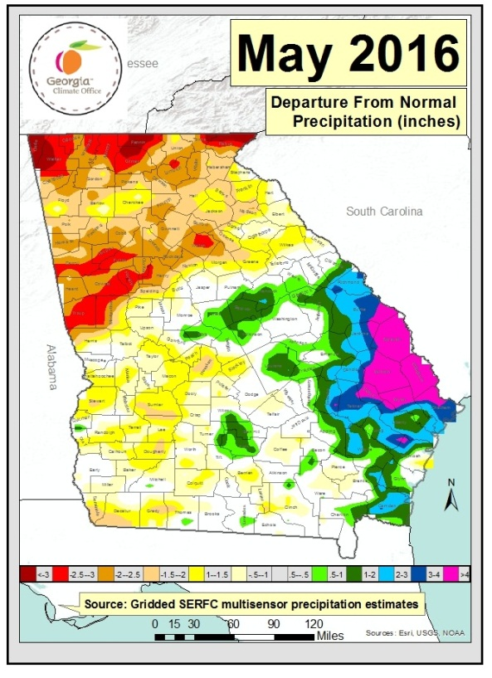
Atlanta had an average May temperature of 71.1° (+1.0°), Athens recorded 70.3° (+0.3°), Macon’s average temperature was 71.8° (-0.1°), Columbus recorded 72.5° (-0.5°), Augusta’s May temperature was 70.7° (-0.4°), and Savannah recorded 74.0° (+0.7°). St. Simons Island was the only major climate site to break or tie any daily temperature records. On May 6th, a daily record low was tied when the low temperature reached 50° (previously set in 1973), and on May 2nd a high minimum temperature was tied when the temperature reached 73° (previously set in 2012).
Precipitation was a mixed bag throughout the state in May. Atlanta saw well below normal rainfall with 1.25" (-2.42"), making it the 11th driest May on record. In addition, this Spring (March through May) was the 6th driest on record with a total of 6.61”. Several other sites saw slightly below normal precipitation, including Athens with 2.49" (-0.51"), Columbus with 2.51" (-0.68"), Macon with 1.96" (-0.76"), and St. Simons Island with 1.68" (-0.18”). Augusta saw above normal precipitation with 5.71" (+3.06"), and on May 29th a daily record was broken when 2.28” fell, breaking the old record of 2.08” in 2001. Savannah had a record-breaking month in terms of rainfall. This May, 8.99” (+6.01”) inches fell, making it the 5th wettest May on record and the 10th wettest Spring on record with 16.26” total in March, April, and May. On May 15th, 2.29” of rain fell and broke the previous daily record of 1.62” set in 1980.
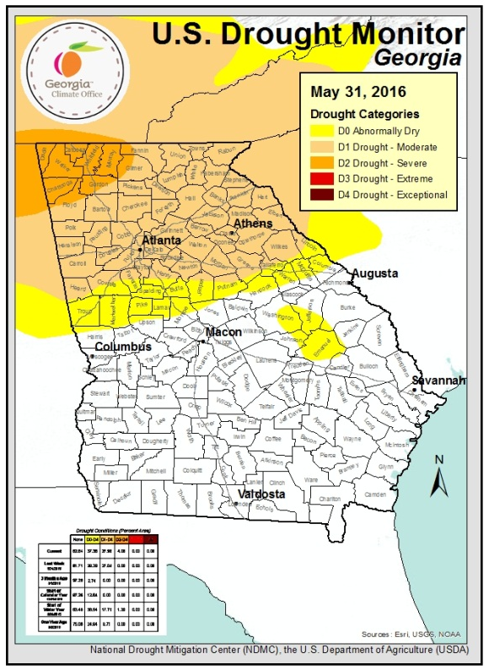
There were several days of wind and hail reports associated with fast moving frontal systems in May, but only one EF-1 tornado was reported in Chatham County in the city of Bloomingdale on March 17th. Winds were estimated to be 90 to 95 miles per hour with mostly just uprooted trees and wind damage.
For the month of May, The United States Drought Monitor for Georgia showed that drought conditions worsened in north Georgia, particularly in the extreme northwest where D2 (severe drought) was introduced. The northern half of the state is in D1 (moderate drought) and D0 (abnormally dry) conditions. During May, areas of D0 in southeast and east-central Georgia were eliminated due to above normal rainfall. Conditions in the northern half of the state will need to be monitored as we transition into a summertime pattern with hot temperatures and more evapotranspiration, which could allow soil moisture conditions to worsen.
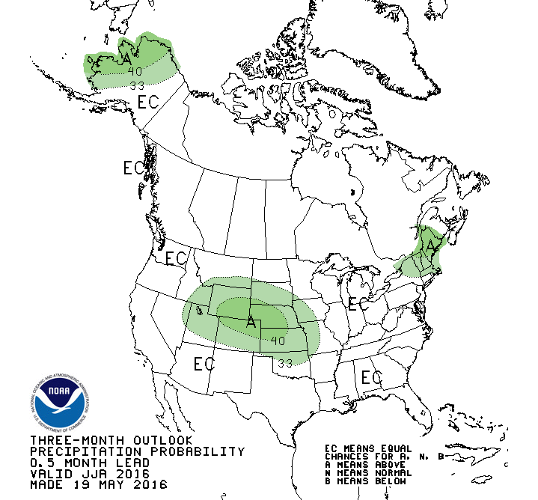
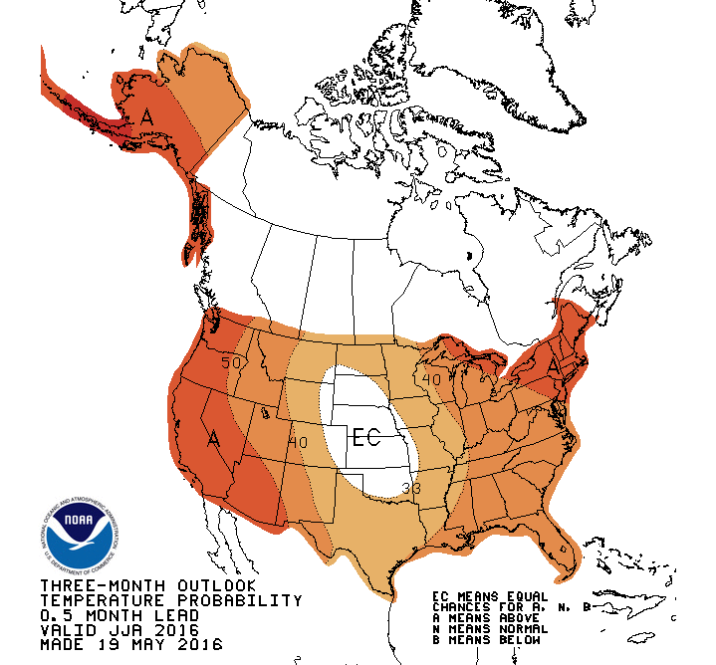
According to the Climate Prediction Center, El Niño is weakening and there is currently an El Niño Advisory and a La Niña Watch. Positive equatorial sea surface temperature anomalies are diminishing across the equatorial Pacific Ocean. La Niña is favored to develop during the Northern Hemisphere summer 2016, with about a 75% chance of La Niña during the fall and winter 2016-17. In the CPC’s three-month seasonal outlook, there are chances for above normal temperatures with an equal chance for above, near, or below normal precipitation in June, July, and August.

