

**Roadway Drainage Structure Exemption from Stream Buffer Variance Requirements**

To ensure that staff throughout the Georgia Environmental Protection Division (EPD), the Georgia Department of Transportation (GDOT), and other interested and affected parties have a consistent understanding of the requirements for buffer variances where there is a stream crossing and related roadway drainage structure, this document describes the related legal authority and includes guidance for how to apply the exemption for the construction of roadway drainage structures.

This document provides clarification and guidance related to the information provided in the September 20, 2010, memorandum from Jim Ussery entitled “Buffer Variance Issues” and the related June 8, 2006, memorandum from Bert Langley. Since those memoranda were issued, the Georgia Erosion and Sedimentation Control Act, O.C.G.A. § 12-7-1 *et seq.* (GESA) and related regulations have been amended. EPD also has had over a decade of experience working with that guidance. As a result, EPD has identified areas where clarification and refinement will lead to better and more straightforward application of the related requirements, and greater consistency with current legal authority. Further, although those prior memoranda were directed exclusively to GDOT, this issue affects all entities who may engage in construction in a stream buffer. Replacing those earlier documents with one of more general applicability is thus more appropriate.

**Legal Background**

GESA

Under GESA, buffer variances are required for all land disturbing activity taking place within the defined buffers of waters of the state or delineated coastal marshlands, unless one of the specific enumerated exemptions apply. *See* O.C.G.A. §§ 12-7-6(b)(15)-(17), (b.1), 12-7-17. One such exemption is for construction projects carried out by or financed by GDOT. *Id.* at 12-7-17(9). Further, Georgia regulations provide that a stream buffer variance is not required for any entity for land disturbing activity in the buffer “where roadway drainage structures must be constructed.” Ga. Comp. R. and Regs. 391-3-7-.05(1)(c).[1] A “roadway drainage structure” is defined in GESA as “a device, such as a bridge, culvert, or ditch, composed of a virtually nonerodable material such as concrete, steel, plastic, or other such material that conveys water under a roadway by intercepting the flow on one side of a traveled way consisting of one or more defined lanes, with or without shoulder areas, and carrying water to a release point on the other side.” O.C.G.A. § 12-7-3(13).

GWQCA

Land disturbing activity may also be subject to requirements under the Georgia Water Quality Control Act, O.C.G.A. § 12-5-20 *et seq.* (GWQCA) and federal Clean Water Act. *See also id.* at 12-7-18 (GESA does not authorize any violations of the GWQCA); § 12-7-6(a)(3) (reference to state general permits under GWQCA). The GWQCA and federal Clean Water Act require that land disturbing activity meeting certain parameters be authorized pursuant to a construction stormwater NPDES permit. *E.g.,* § 12-5-30(f). Most typically, road construction work proceeds under GAR100002, the NPDES Construction General Stormwater Permit for Infrastructure Construction Projects (Permit).

Construction Stormwater General Permit

The construction general stormwater Permit mandates that a buffer variance be obtained from EPD for any work in stream buffers; in the 2018 version of the Permit this language appears in Section IV(i)-(ii).[2] This is consistent with GESA, which requires that GDOT (and its contractors) create and maintain compliance with an Erosion, Sedimentation and Pollution Control Plan (Plan), including best management practices to protect water quality, and which specifically states that compliance with the GWQCA is required. *Id.* at §§ 12-7-7.1(e), (g), 12-7-18.

Any permittee, including GDOT, proceeding under the Permit must obtain stream buffer variances for all land disturbing activity carried out under the Permit that disturbs the 25-foot or 50-foot stream buffer. *See* 2018 Permit at Section IV. The Permit, however, specifically exempts from this variance requirement land disturbance in the stream buffer “where a roadway drainage structure must be constructed.” Permit Section IV(i)-(ii). Because the Permit also references the requirements of GESA, the definition of “roadway drainage structure” in that statute applies. *See* *id.*; *see also* O.C.G.A. § 12-7-3(13). Further, in the definition of “roadway projects,” “traveled ways” are described to include roads, sidewalks, paths, trails, and airport runways and taxiways. Permit I.B.36.

**Applying the Roadway Drainage Structure Exemption**

Applying this legal framework to individual projects can be challenging. Depending on the stream channel, location of the road project, type of drainage structure, and other topographical and physical features, the form and structure of the roadway and associated drainage structures will vary. This may mean that some land disturbing activity is exempt from the buffer variance requirement because it is part of roadway drainage structure construction, while other associated activity is not exempt. This document sets out guidance for determining the typical amount of area necessary to construct a roadway drainage structure and to facilitate the determination of what type of land disturbing activities are exempt from state mandated buffer requirements.

Any stream crossing structure, i.e., a bridge, necessarily will involve some roadway drainage structure construction within the buffer and for some amount of the road as it approaches the stream. In addition, to construct the roadway drainage structure may trigger the need to relocate existing structures or utilities. That work—the roadway drainage structure construction and the land disturbing activities required to remove existing utilities or structures to accommodate a roadway drainage structure—is exempt from the stream buffer variance requirement. Other aspects of constructing or expanding a road or stream crossing structure—such as constructing the new, relocated utility trench—are unrelated to the construction of the roadway drainage structure and, thus, are *not* exempt from the buffer variance requirement. Ga. Comp. R. and Regs. 391-3-7-.05(1)(c); 391-3-7-.11(1)(e).

Based on EPD’s experience in reviewing and assessing stream buffer variance applications and road construction projects, along with input from stakeholders, EPD has assessed the area of disturbance typically necessary to construct the drainage structures. For a bridge, that area typically includes soil compaction along the traveled way in a radius of approximately one hundred (100) feet from the bridge or, as appropriate, a box of one hundred (100) by one hundred (100) feet in dimension, as measured from the roadway drainage structure. For a culvert, soil compaction along the traveled way in a radius of approximately fifty (50) feet from the culvert, or, as appropriate, a box of fifty (50) by fifty (50) feet in dimension, as measured from the roadway drainage structure. Whether the radius or box structure is most appropriate will depend on the nature of the roadway drainage structure (e.g., does the culvert have angled wing walls?) and topography.

That compaction work is exempt from the variance requirement as part of construction of a roadway drainage structure; that is, a radius or box of either 100 feet or 50 feet of compaction as measured from the bridge or culvert structure does not require a buffer variance. Obviously, land disturbance should be kept to a minimum and only the areas necessary for roadway drainage structure construction activities should be disturbed. In addition, other proposed buffer disturbance within that radius or box that is not directly necessary for the construction of the roadway drainage structure itself does require a buffer variance, even if the disturbance may be associated with construction of the bridge or culvert.

In the below examples, soil compaction and utility/roadway structure removal necessitated by roadway drainage structure construction itself that occurs within the areas outlined in red is exempt from the requirement to obtain a buffer variance. All *other* land disturbing activity in the stream buffer, including activity within the areas outlined in red, will require a buffer variance.

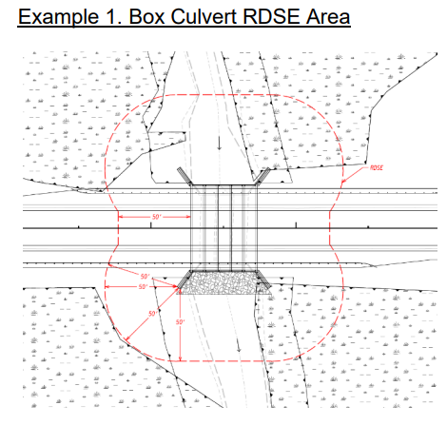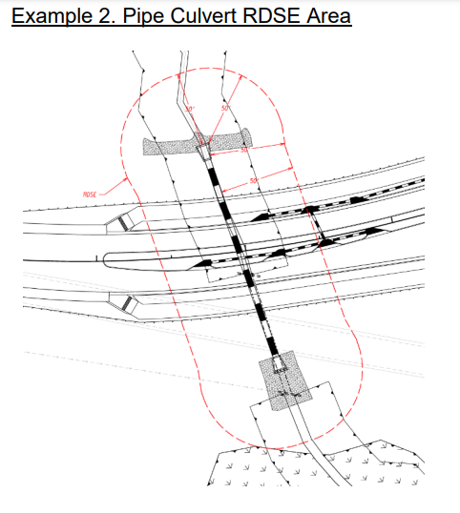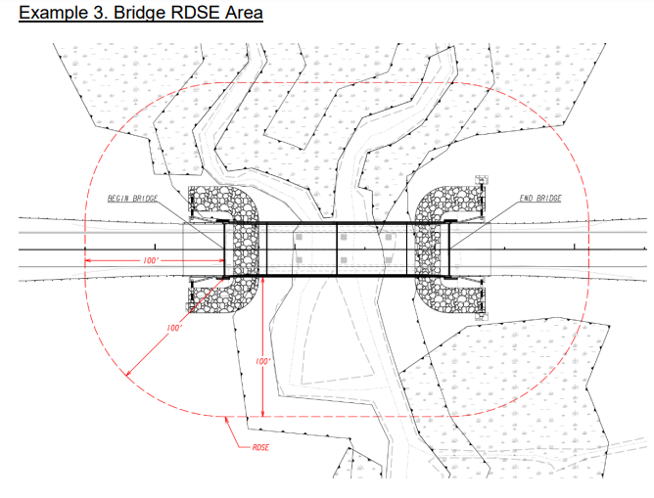

For projects with an associated buffer variance request, the boundaries of the exemption area(s) should be accurately delineated on the required Plan sheets. The work to be carried out within those boundaries should also be described on the Plan, including whether the work is or is not related to the construction of a roadway drainage structure or to remove existing utilities or structures to accommodate a drainage structure.

There may be situations where construction of a roadway drainage structure may require disturbance that exceeds the 100 feet for a bridge or 50 feet for a culvert describe above. For those situations, before conducting any land disturbing activity the entity seeking to work under the roadway drainage structure exemption must first submit in writing to EPD’s Nonpoint Source Program, Watershed Protection Branch, documentation showing the exact additional area proposed to be disturbed, a description of the work to be performed in that area, and their rationale for why the exemption applies. EPD will review that submission.

If EPD determines that the additional disturbance is necessary, it will respond in writing with a description of the exact amount of area and type of work in that area that EPD has determined is exempt from the buffer variance requirement. EPD will also provide a copy of that letter to the appropriate District Office. No land disturbing activity should be conducted until this letter from the EPD Nonpoint Source Program has been received.

1. There is a similar exemption for construction or maintenance of a drainage structure or roadway drainage structure in a coastal marshland buffer. Ga. Comp. R. and Regs. 391-3-7-.11(1)(e). Because the roadway approach and crossing issues for those buffers are different than for stream buffers, that exemption is not addressed in this document.
2. Likewise, there is an exemption for construction or maintenance of drainage structures or roadway drainage structures in coastal marshland buffers. Permit at Section IV(iii).