**GUIDE TO SUBMITTING CORRECTIVE ACTION REPORTS THROUGH GEOS**

Important Information: Account Creation, Association, and Report Preparation

* This guide assumes the responsible official has created an account and associated their facilities and submittal types. For more information on creating accounts and associating facilities and submittal types, see: <https://epd.georgia.gov/geos/documents>.
* Please note that the most complicated part of submitting reports through GEOS is understanding roles, creating an account, and associating facilities and submittal types.
* When associating facilities to your account, you will find the available submittal types next to the available facilities. A submittal type in GEOS corresponds to specific type of corrective action report (UST Closure Report, CAP-A, etc.). **The Program recommends selecting all the available submittal types for each facility you are associating.**
* **It is imperative that you associate the correct facility and submittal types. GEOS will not allow you to submit your report if associations are not completed correctly.**
* GEOS is used to submit standard corrective action reports, not general correspondence such as extension requests, notifications of contact changes, etc.
* The submittal of reports through GEOS does not change how you prepare a technical report and any reimbursement applications. As currently required when submitting a hard copy, a reimbursement application must accompany the report if you are seeking reimbursement.
* Monitoring Report submittal type: For submitting routine reports on sites that are only under an approved monitoring natural attenuation program. Progress Report submittal type: For submitting routine reports on sites that are undergoing any kind of remediation, even if that remediation is sporadic.

Important Information: Submitting a Report through GEOS

* The submittal process is nearly identical for each submittal type…the only thing that changes is the data required to be entered into the system.
* Most of the submittal types will ask you a series of site-specific questions that you obtain from the report itself. The submittal types requiring this information, and the corresponding questions for each submittal type, can be found at the end of this document.
* This guide will walk you through the submittal of one of the more complex submittal types, the “Progress Report”.
* You will submit a report and reimbursement application as a single submittal, but during the submittal process, you will upload these **entire** documents as separate files. For example, if you are submitting a CAP-A and reimbursement application, you will select the submittal type of CAP-A/Revised CAP-A.
* You should only choose the submittal type of “GUST Trust Fund Request for Reimbursement” in the rare case you are submitting a reimbursement application by itself.
* Any data, information, or uploads submitted through GEOS is available for the public to view. The USTMP has revised reimbursement application forms to remove sensitive information such as social security numbers and FEI numbers. **Please ensure that any data, information, or uploads submitted through GEOS do not contain sensitive information.** If you encounter a form that has not been updated, please leave sensitive information blank.
* Most fields in GEOS are required to be completed (designated with a red asterisk). In the case where the information is not known but required, please enter “9999” if it is a numeric field or “abcd” if it is a text field.
* **Uploaded files should be PDFs only.**
* **GEOS will time you out…save often!!**
* **The USTMP highly recommends you contact your assigned project officer when submitting a report for the first time in GEOS.**

Steps Required to Submit a Corrective Action Report

1. Click on “Start New Application”:

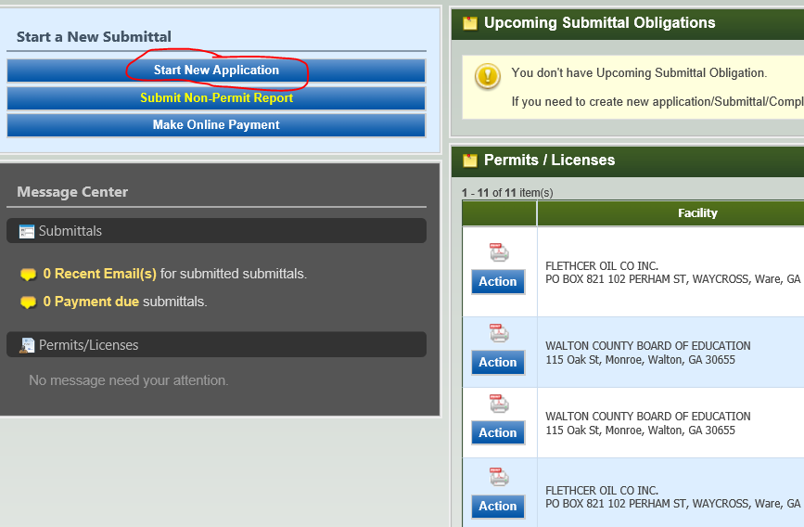

2. Select the Submittal Type from the available options. In this example, we will submit a Progress Report:

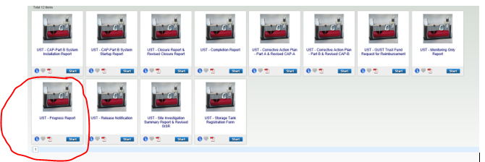

3. After selecting a submittal type, GEOS will navigate you through a series of webpages containing notifications and data requests. The first page is simply a reminder of the submittal type you have chosen. Click “Next” to go to the next page.

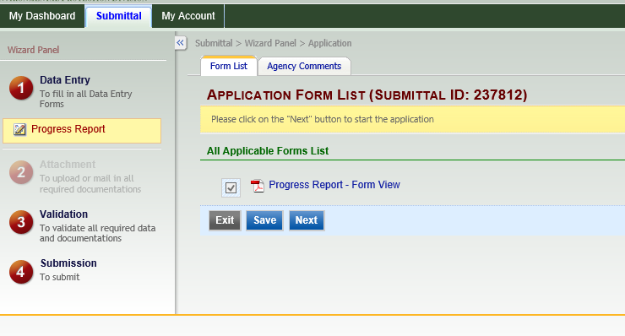

4. The next page is the most complex because it contains several fields requiring data from the user. This page is broken down into three categories of required information: Facility Information, General Information, and Payment Request. General Information and/or Payment Request may not be required for certain submittal types.

5. For Facility Information, most of the required data should auto-populate once you select the appropriate facility from the dropdown menu. Only those facilities associated to your account will be available in the dropdown. If the facility is not available in the dropdown, please contact your assigned project officer before continuing. Below is a screenshot of Facility Information that auto-populates after the facility was selected from the dropdown:

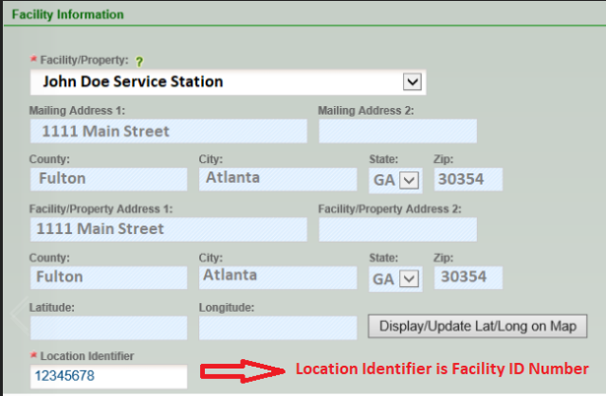

The only field that does not auto-populate is the “Location Identifier”. **“Location Identifier” is the Facility ID Number. Do not include an asterisk or release number.**

6. The first part of “General Information” is tank owner and consultant contact information. Below is a screenshot of this part completed by the user:

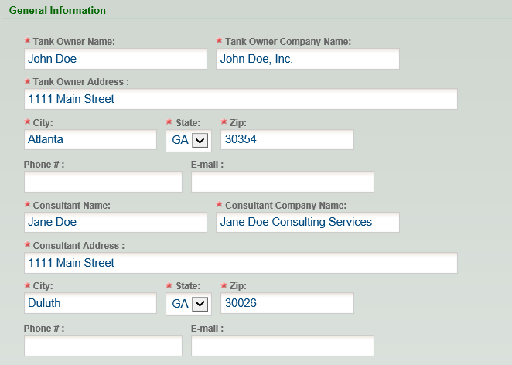

7. The next part of “General Information” is site specific data. Below is a screenshot of this part completed by the user. Most of the required fields are intuitive. Items circled in red are explained below since they may not be intuitive:

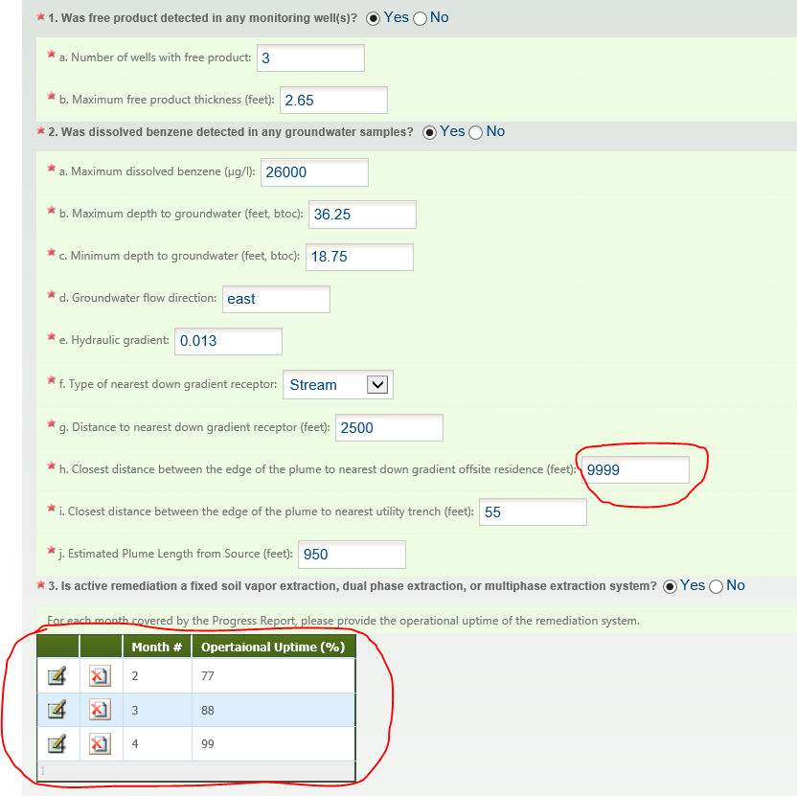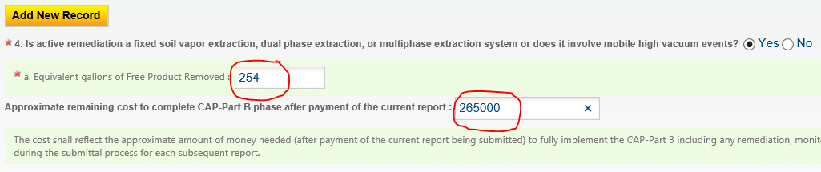

The distance between the edge of the plume to the nearest downgradient offsite residence will not likely be known because the USTMP has not implemented the RBCA model yet.

For active remediation that includes SVE, DPE, or MPE, you are required to provide operational uptime for each month in operation and the equivalent gallons removed over the **entire** operational period. In this example, the system was operational February (Month 2), March (Month 3), and April (Month 4) and it removed a total of 254 equivalent gallons of product.

The “Approximate remaining cost to complete CAP-Part B phase…” is an estimate of how much more money is needed to bring the site to completion (NFA and well abandonment) after payment of the current report being submitted. It is only an estimate and used for budgeting purposes.

**For the CAP-A and SISR submittal types, you will be asked a similar question, “Approximate remaining cost to complete CAP-A phase…” This is an estimate of how much more money is needed (after payment of the current report being submitted) to complete all CAP-A activities including preparation of the CAP-B. Again, it is only an estimate.

8. The last section of this page is “Payment Request”. For owner/operator funded sites or sites in which you are not seeking reimbursement, you will always select “No” when asked if you want to submit a payment request with your report. The first part of this section is basic information such as the type of reimbursement, payee contact information, and the amount requested:

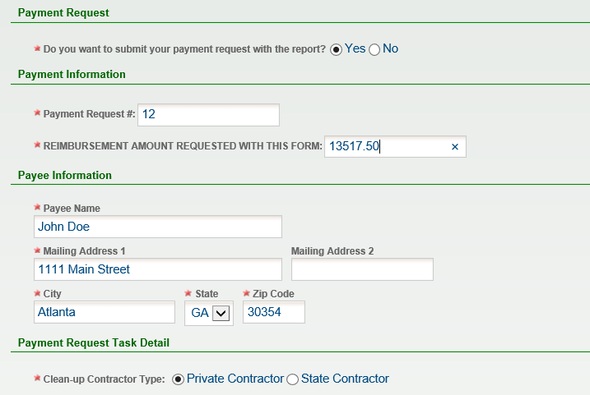

Answer “No” if you are not seeking reimbursement.

**This guide does not cover state contractor reimbursement. Contact your assigned project officer for state contractor reimbursement.**

9. When selecting “Private Contractor” reimbursement, you must enter in incurred costs for the current report, proposed costs for the next report, and invoices. Due to the complexity and time commitment of sending submittals back to the user to revise costs, the Program highly recommends that the proposed scope of work and proposed costs be finalized between the project officer and consultant (outside the GEOS system) prior to submitting the report in GEOS.

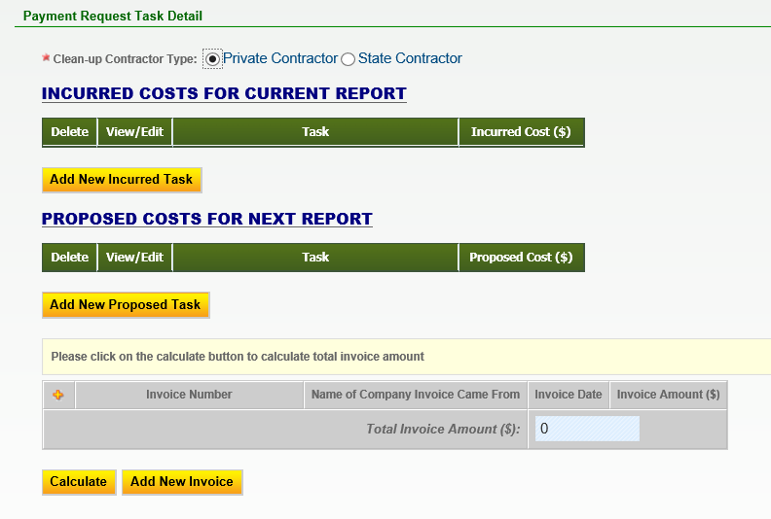

The system is capable of capturing broad and detailed costs. Therefore, if you select “Add New Incurred Task”, you are given several task elements to choose from. For now, you will only select “Miscellaneous”:

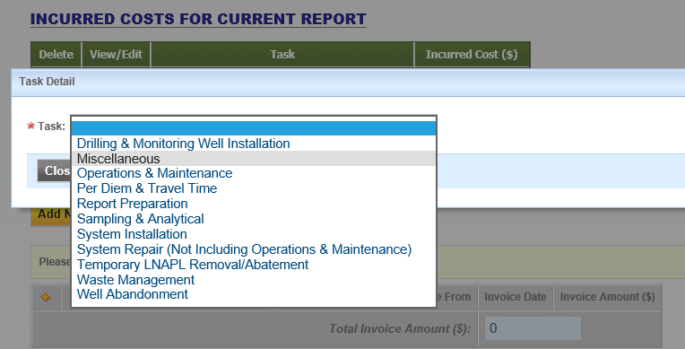

**You will select “Miscellaneous” for each incurred task completed on the cost review form (CRF).** So, let’s say Task 1 and Task 2 of the CRF for this Progress Report were incurred. In this case, you will select and complete a new Miscellaneous item for Task 1 and you will select and complete a new Miscellaneous Item for Task 2. This is what it may look like:

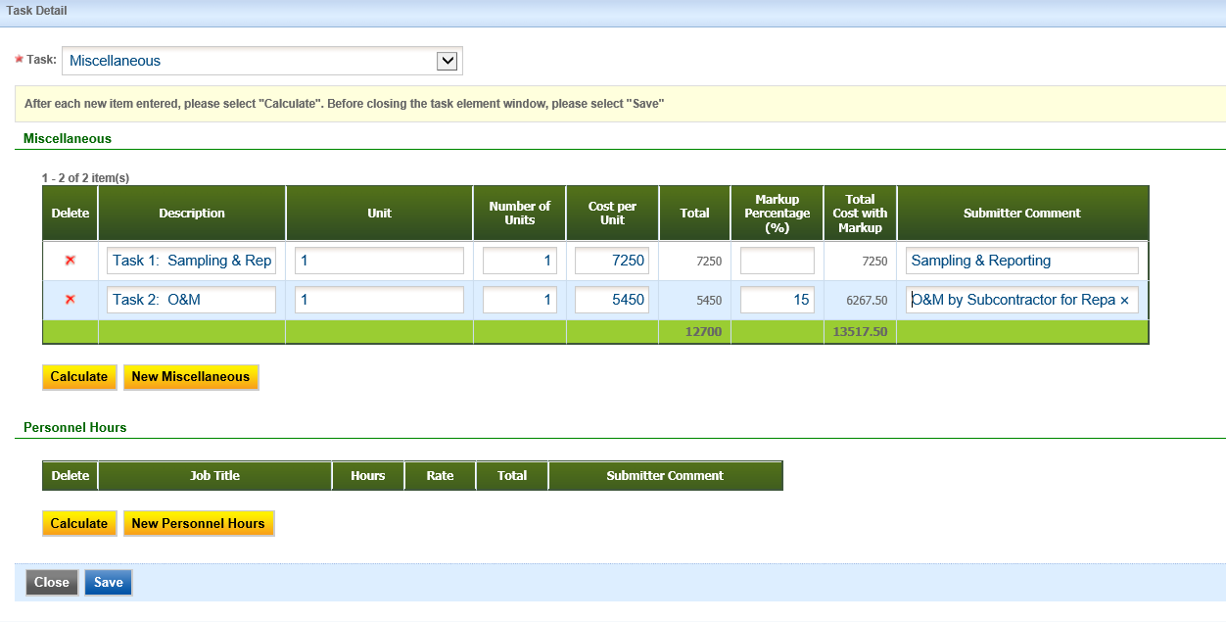

**For Description, include the corresponding task number from the CRF.**

**Unit will be “Each” or “1”**

**Number of Units will be “1”**

**Cost per Unit will be the total for that task.**

**Ignore Personnel Hours**

**Click “Calculate” after each task is completed. Click “Save” when all tasks have been completed.**

10. Repeat Step 9 for Proposed Costs for Next Report. However, in this case, you will only capture the costs to complete proposed tasks as outlined in the CRF. So, if Task 3 and Task 4 include costs for proposed for work that will be documented in the next report, you will have two “Miscellaneous” items, with one corresponding to Task 3 and the other corresponding to Task 4.

11. The last part of this “Payment Request” section is to list all invoices in the reimbursement application. These invoices should correspond to the GUST-4D of the CRF. The following screenshot shows what the webpage will look like when the incurred costs and invoice sections have been completed. The proposed costs section was left blank to fit the screenshot on one page:

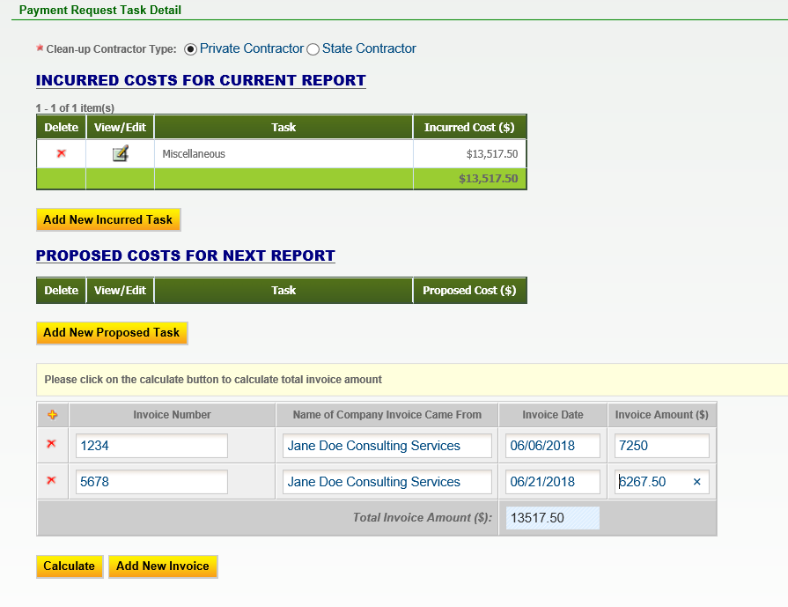

**In most situations, the total of the incurred costs should equal the invoice total and the reimbursement amount requested.**

12. Click “Save” at the bottom of the page and then “Next”.

13. The next page in GEOS is the “Attachment” page. It is where you upload the report and reimbursement application. The report should be scanned as a single PDF document and uploaded under the “Supporting Documents for Progress Report” heading. The reimbursement application should be scanned as a single PDF document and uploaded under the “Supporting Documents for Payment Request” heading.

The file limit size is approximately 10 MB. Most reports, even the voluminous CAP-Part B, can be scanned at under 10 MB if the appropriate settings are used. If the file size is larger than 10 MB, you will need to logically split the report into separate files such as a report file, figures file, and a lab data file. **If a report needs to be split up into separate files, please contact your assigned project officer.**

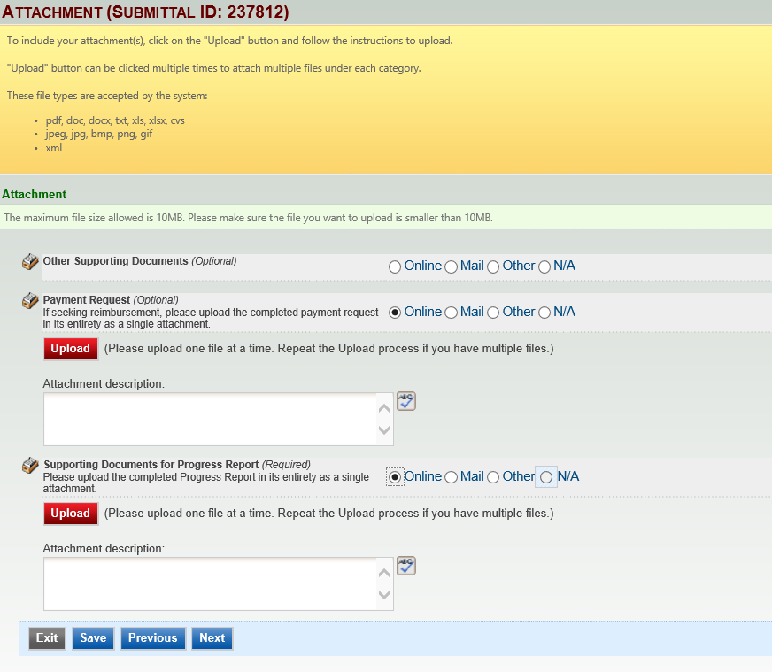

14. Browse where the files are stored on your computer and upload them accordingly. Once the files are uploaded, select “Save” then “Next”.

15. The next page is simply a validation page that confirms all requirements have been met.

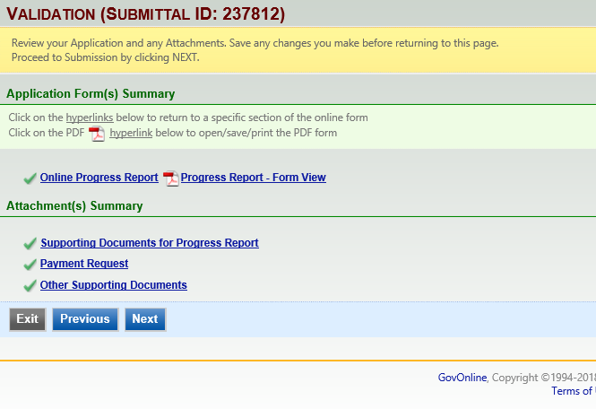

16. Select “Next” if everything has a green check. If there is a red “x”, then you will need to make a correction.

17. The final page is the submittal page. You will need to know the answers to your security questions and your pin. Both are generated during account creation. Select “Submit” once you provide the answer to your security question and security pin.

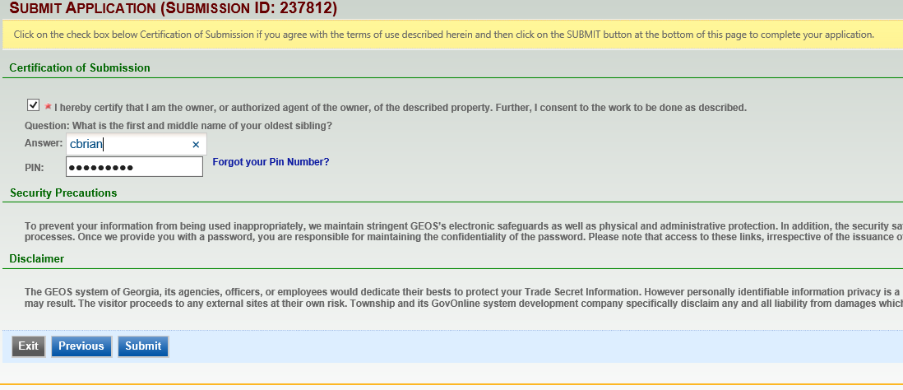

GEOS SUBMITTAL TYPES REQUIRING SITE SPECIFIC RESPONSES

RELEASE NOTIFICATION



UST CLOSURE REPORT



CAP-PART A



CAP-PART B



MONITORING REPORT



PROGRESS REPORT

