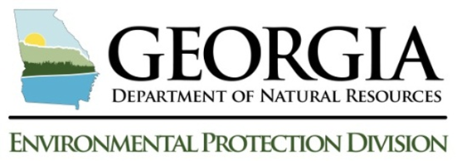
For Official Use Only
Permit

State of Georgia - Department of Natural Resources

Notice of Termination for Animal Feeding Operations

ANIMAL FEEDING OPERATIONS
Check one:
☐ General NPDES Permit No. GAG930000 ☐ General LAS Permit No. GAU700000

☐ General LAS Permit No. GAG920000 ☐ General LAS Permit No. GAG940000

Section I. FAcility Location Information
Facility Name:
Facility Phone No: |  | E-mail Address:
Facility Mailing Address:
City: | State: | Zip Code:
County: | SIC Code:
Section II. FAcility Owner – Operator information (as it appears on the notice of intent)
Owner-Operator’s Legal Name:
Owner Phone No: |  | E-mail Address:
Owner Address:
City: | State: | Zip Code:
County:
SEction III. Site Activity Information
1. Is this operation closing? ☐ Yes ☐ No If no, how many animals will be kept on the operation?
2. Please list the maximum number and type of animals that will be confined or fed for a total of 45 days in any 12 month period:
Number: | Type:
Number: | Type:
Number: | Type:
3. Describe the animal feeding/growing operation in the space below.
4. Describe the reason(s) for submitting the Notice of Termination in the space below.
Section IV. Certification
I certify under penalty of law that all animal feeding operations associated with the identified facility that are authorized by the General NPDES Permit No. GAG930000, General LAS Permit No. GAU700000, LAS Permit No. GAG920000, or LAS Permit No. GAG940000 have been eliminated, the identified facility has been properly closed in accordance with the approved nutrient management plan, or the owner-operator of the identified facility has changed and that owner-operator is authorized under General NPDES Permit No. GAG930000, General LAS Permit No. GAU700000, LAS Permit No. GAG920000, or LAS Permit No. GAG940000. I understand that by submitting this Notice of Termination, that I am no longer authorized to operate an animal feeding operation of the size and type associated with the corresponding general permit, and that such operation is unlawful under the Georgia Water Quality Control Act and the Federal Clean Water Act where the operation is not authorized by the appropriate NPDES or LAS permit.
Printed Name: |  | Title:
Signature: |  | Date:
Mail or fax this completed form to:
Georgia Department of Agriculture; 19 Martin Luther King Jr. Drive SW; CAFO Coordinator-Room 112; Atlanta, Georgia 30334-4201
Phone (404) 656-3665 ext. 1303 Email Address: Courtney.Wilson@agr.georgia.gov

