**How to submit a Notice of Intent using GEOS**

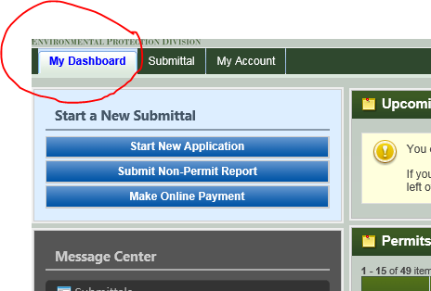

Once you have created or logged in to your account, look for the “**My Dashboard**” tab in the menu near the top of the screen.

**Just below the “My Dashboard” tab are three choices.**

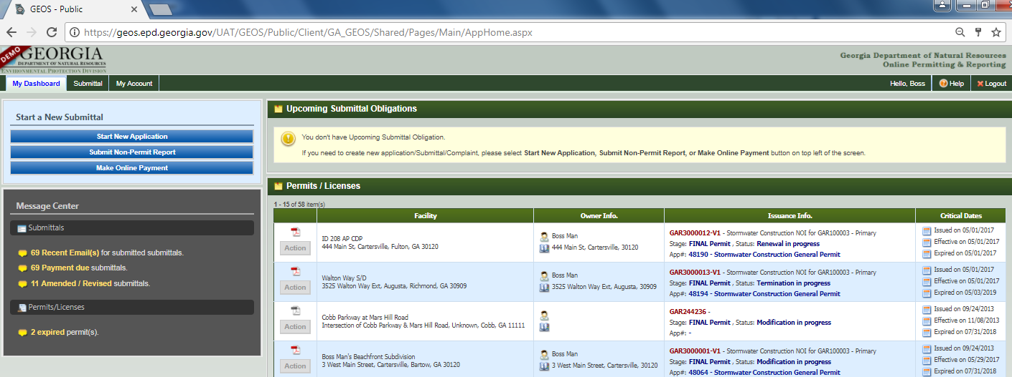



To create a new NOI, select “**Start New Application**”. Go to Page …

Select to Submit Non Permit Reports. Go to Page …

Select to Make Online Payments. Go to Page …

**NPDES Department Submittal Type List**

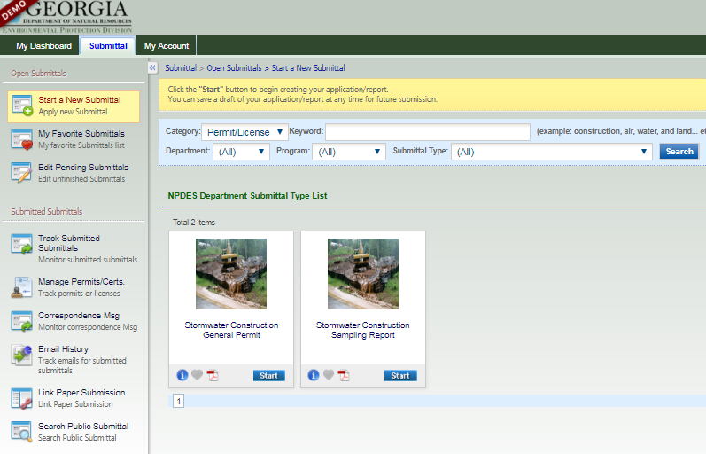

To submit Sampling Reports, select “**Start**” under the “**Stormwater Construction Sampling Reports**”. Go to Page …

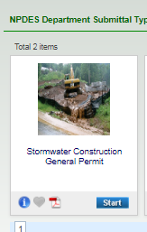

To create a new NOI, select “**Start**” under the “**Stormwater Construction General Permit**”. Go to Page …

**Stormwater Construction General Permit**

Select the appropriate option for the desired permit coverage. Note: New options will appear only if Common Development is selected.

Construction activities that are not part of a common development, where the primary permittee chooses not to use secondary permittees.

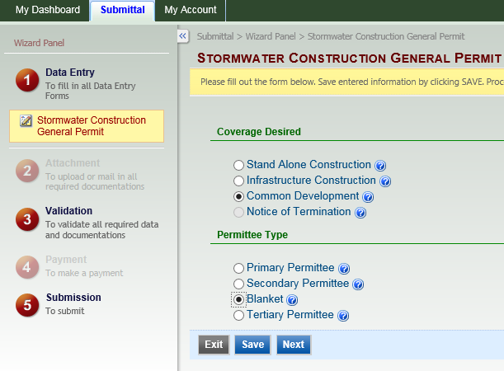

Construction activities that are not part of a common development that include the construction, installation and maintenance of roadway and railway projects and conduits, pipes, pipelines, substations, cables, wires, trenches, vaults, manholes and similar or related structures for the conveyance of natural gas (or other types of gas), liquid petroleum products, electricity, telecommunications (telephone, data; television, etc.), water, storm water or sewage.

A contiguous area where multiple, separate, and distinct construction activities will be taking place at different times on different schedules under one plan of development on or after August 1, 2000.

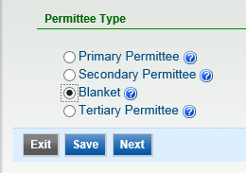

Select the appropriate option for the desired permit coverage. Select “**Next**”.

For a “**Stand Alone**” Permit, go to page …

For an “**Infrastructure**” Permit, go to page…

For a “**Common Development**” Permit, go to page…

**Common Development**

When you Select Common Development, select the appropriate Permittee Type: **Primary Permittee, Secondary, Blanket, or Tertiary**. Select **Next**.

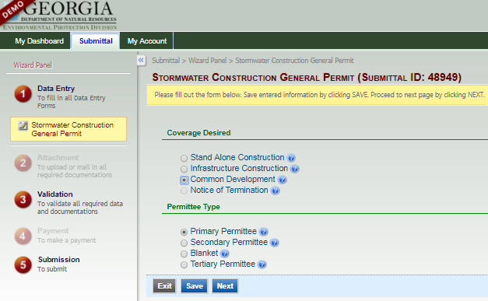

An owner, individual builder, utility company, or utility contractor that conducts a construction activity within a common development with an existing primary permittee.

The Owner or the Operator or both of a tract of land for a construction project subject to this permit.

Means a Notice of Intent to be used by utility companies and/or utility contractors acting as secondary permittees that covers all construction activities in common developments during the calendar year for which the NOI is submitted.

Either the Owner or Operator of a remaining lot(s) within a common development (as defined in this permit) conducting a construction activity where the primary permittee and all secondary permittees have submitted a Notice of Termination in accordance with Part VI.A.2. of this permit (excluding utility companies and/or utility contractors working under a Blanket NOI) or where a primary permittee no longer exists.

**Creating a New Facility**

Click on the “Create New Facility” button to open the “Pop Up” Window to begin entering the Facility Information.

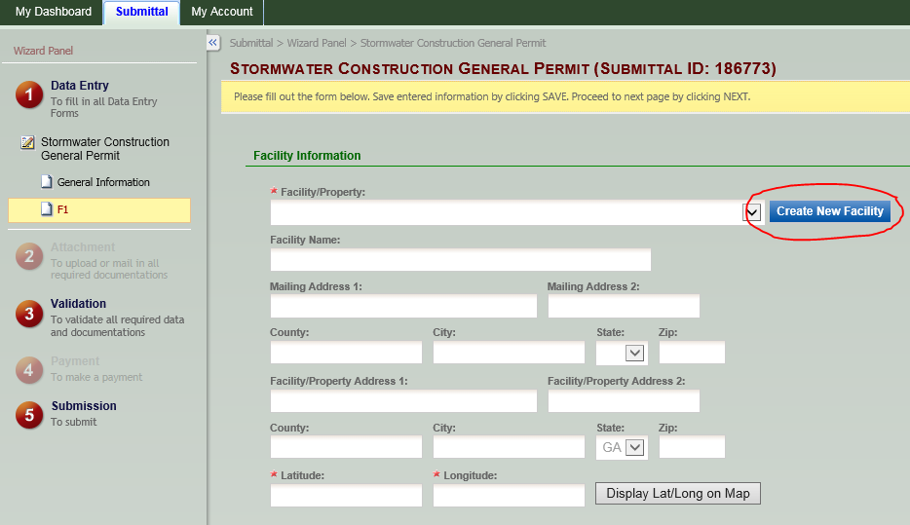

In the “Pop Up” Window, enter the information in the appropriate boxes.

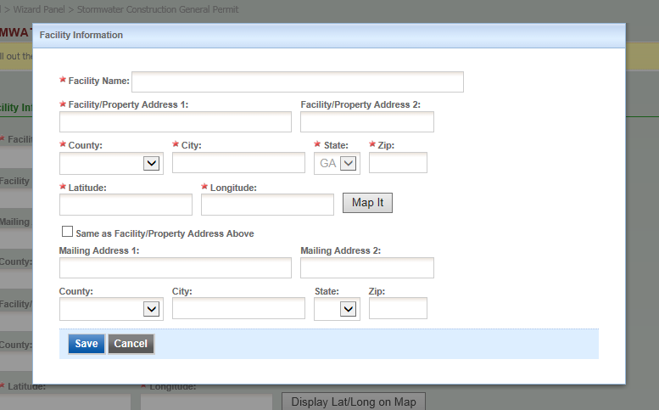

Pop Up Window

All boxes with a red star must be filled in.

**Creating a New Facility (Continued)**

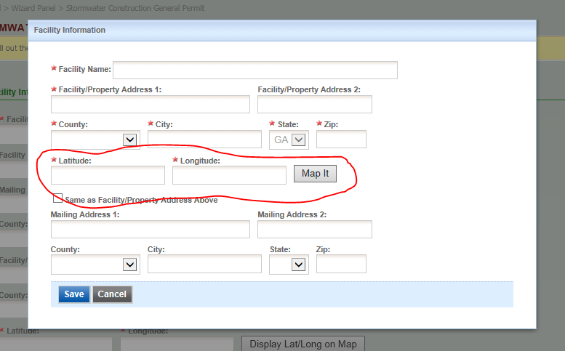

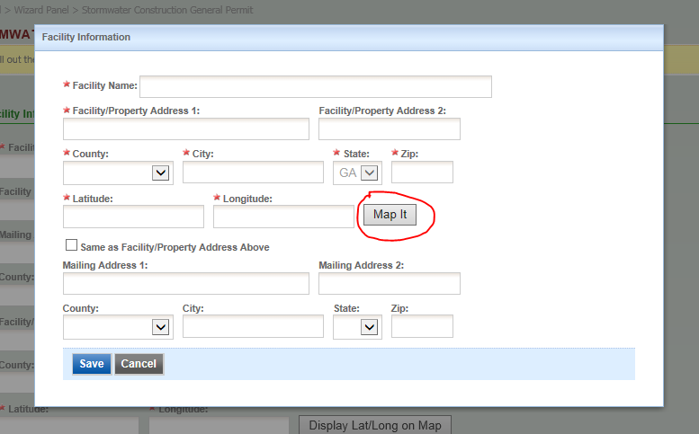

Enter the Lat/Lon in Decimal Degrees

(i.e. Lat 34.6773 Lon -84.6789).

Once the coordinates have been entered, select the “Map It” button to map the site.

**Creating a New Facility (Continued)**

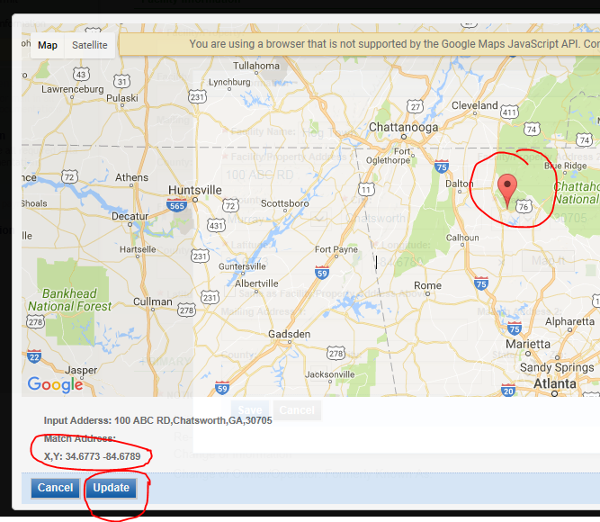

When you select the “Map It” button, a “Pop up” Window appears with a map. On the map will be a pin marking the location of the coordinates that you entered. Check to make sure the coordinates are correct in the lower left hand corner of the map. Select update to update the map with the facility location.

Pop Up Window



Once all the required information has been entered, select “Save”. The “Pop Up” Window will close, and the information will auto populate the Facility fields on the GEOS webpage.

**Creating a New Facility (Continued)**

An example of Facility Information populated on the GEOS webpage.

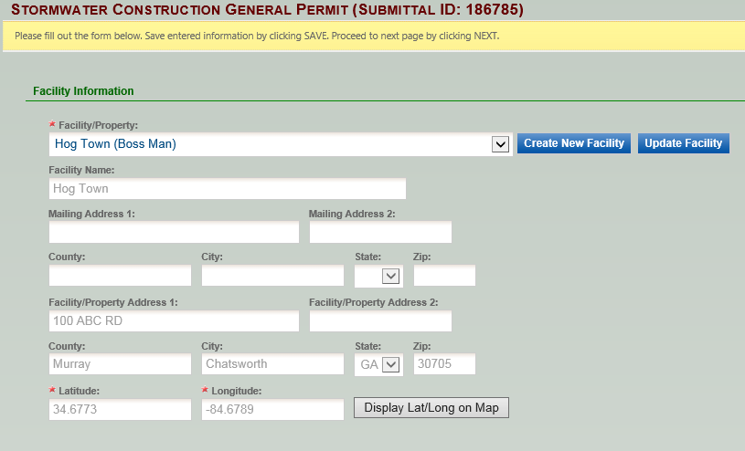

**I.Site/Owner/Operator Information**

Fill out the fields that apply.

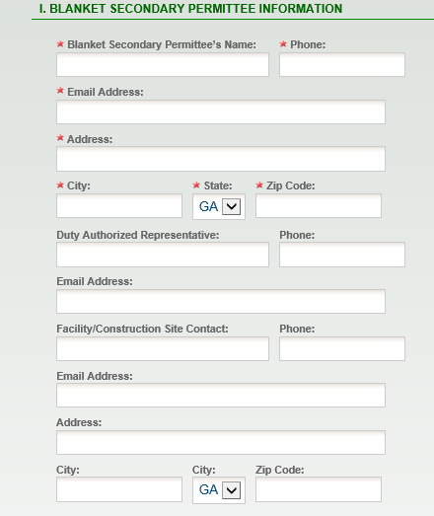

All boxes with a red star must be filled in.

**II. Construction Site Activity Information**

Fill out the fields that apply.

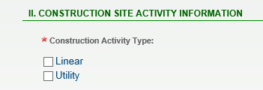

All boxes with a red star must be filled in.

**IV.Certifications**

Carefully read the Certifications

Click both empty boxes to select and confirm agreement.

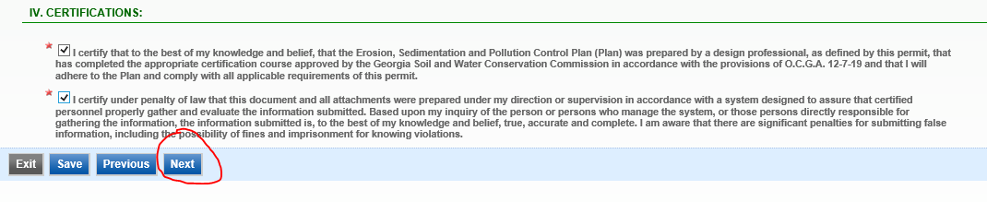

Once the application is certified, select “Next”.

**Attachments**

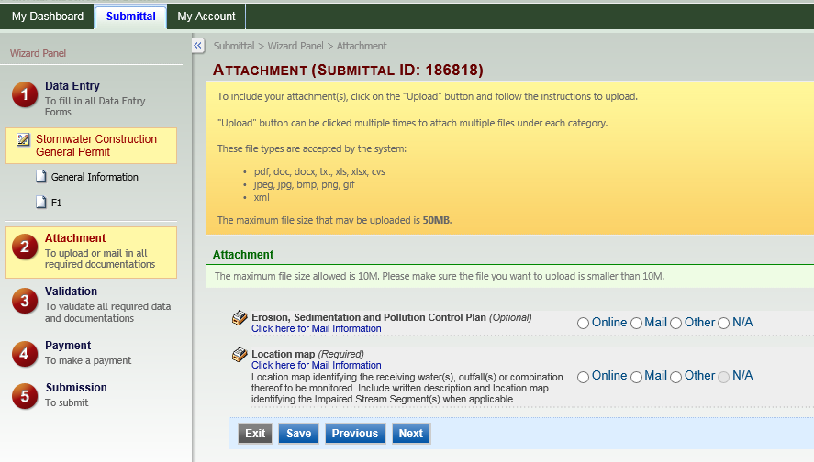

To submit a digital ESPC Plan, select “Online”, and upload the file.

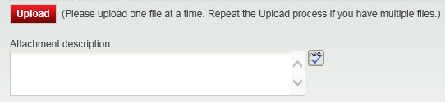

To mail the ESPC Plan, click here to get the mailing address to the appropriate EPD office.

To “Hand Deliver the ESPC Plan, select “Other”.

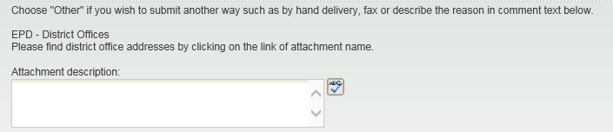

**Attachments (Continued)**



To submit a digital Location Map, select “Online”, and upload the file.



To mail the Location Map, click here to get the mailing address to the appropriate EPD office.

To “Hand Deliver a Location Map, select “Other”.



**Validation**

Review your Application and any Attachments.

**\*Save any changes you make before returning to this page.**

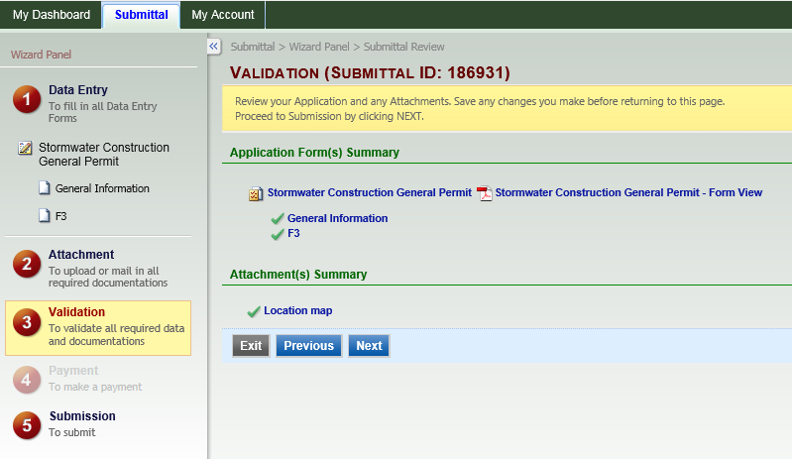

Proceed to Submission by clicking “Next”.

**Submit Application**

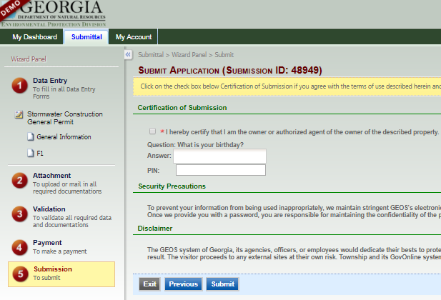

Fill in PIN

Answer the security question.

Click the empty check box to confirm agreement.

Click on the “SUBMIT” button to complete your application.

**Submittal Receipt**

Once you submit your application you will be taken to the Receipt page. 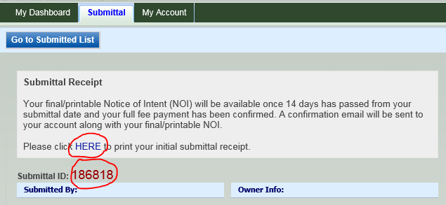

Click the “Here” to print the initial submittal receipt.

Record the Submittal ID for your records.