Instructions to Create a New User Account as a Responsible Official:
- Go to website: https://geos.epd.georgia.gov/GA/GEOS/Public/GovEnt/Shared/Pages/Main/Login.aspx

- Select “Create a new account” on the right side of the screen.
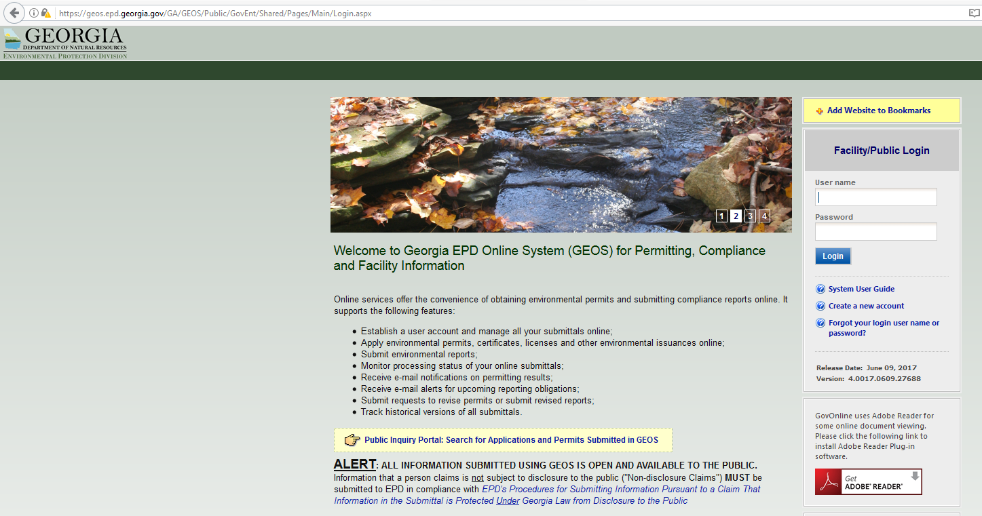

- Select “Responsible Official,” and then select “RO/Owner for Storm Water Construction.”
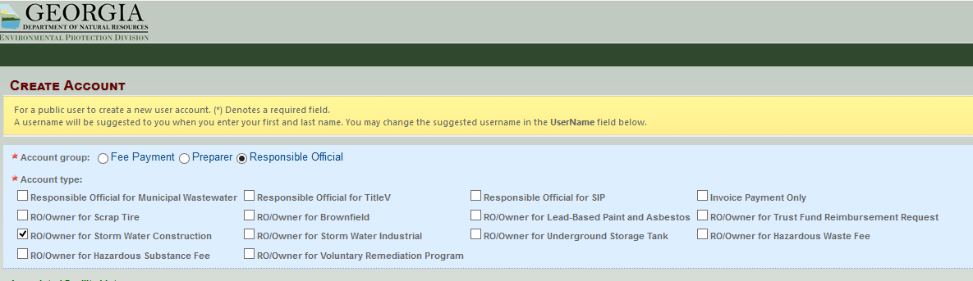

- Select “Next” at the bottom of the screen.
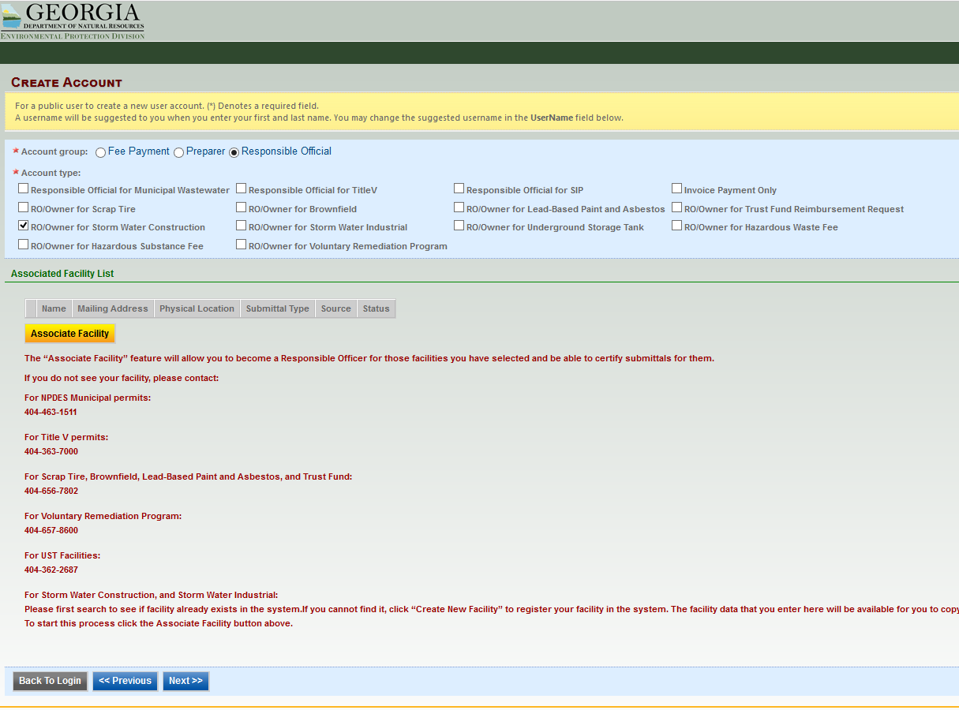

- Answer all 5 of the Security Questions and then select “Next.”
NOTE: REMEMBER your security question answers. When submitting NOIs/NOTs, you will be prompted to use your security question answers and PIN number.

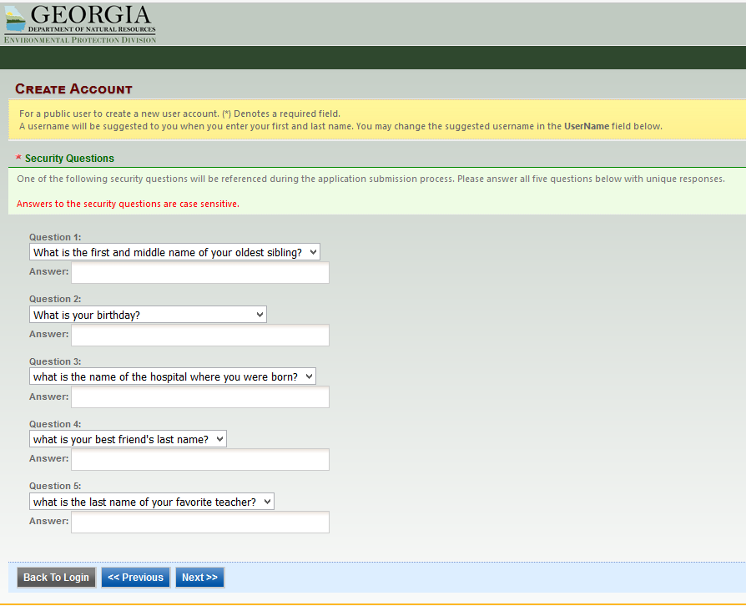

- You will have three options for identity proofing of RO: 1)E-verify, 2) ESA – mailing in a paper form via certified mail (which you will have to do for each facility/site), and 3) Opting out of identity proofing. Attempt the E-verify option first by entering the characters you see from the orange Submit Query box into the box just below it and then select the green “Proceed with e-Verify Option.
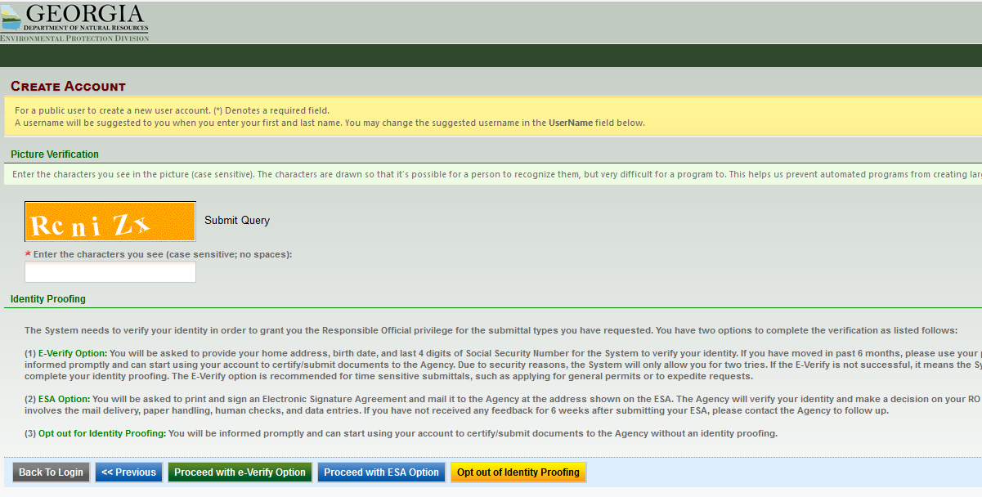

- Select the red “OK.”

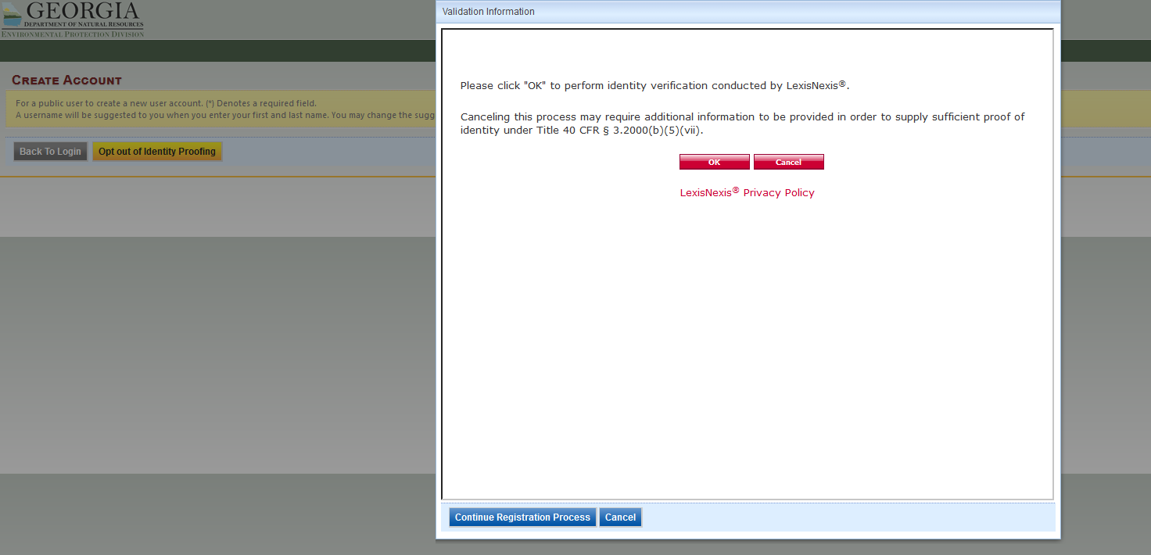
- Fill in all information (make sure your birthdate is in the **/**/**** format) and then select the red “Submit.”

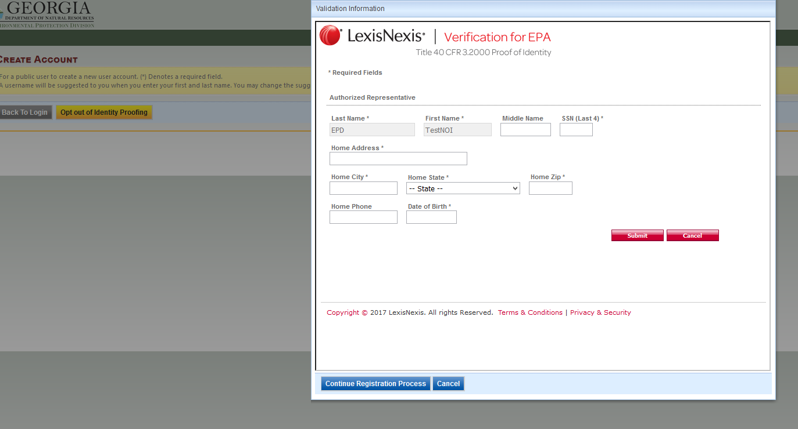

- Select the blue “Continue Registration Process.”
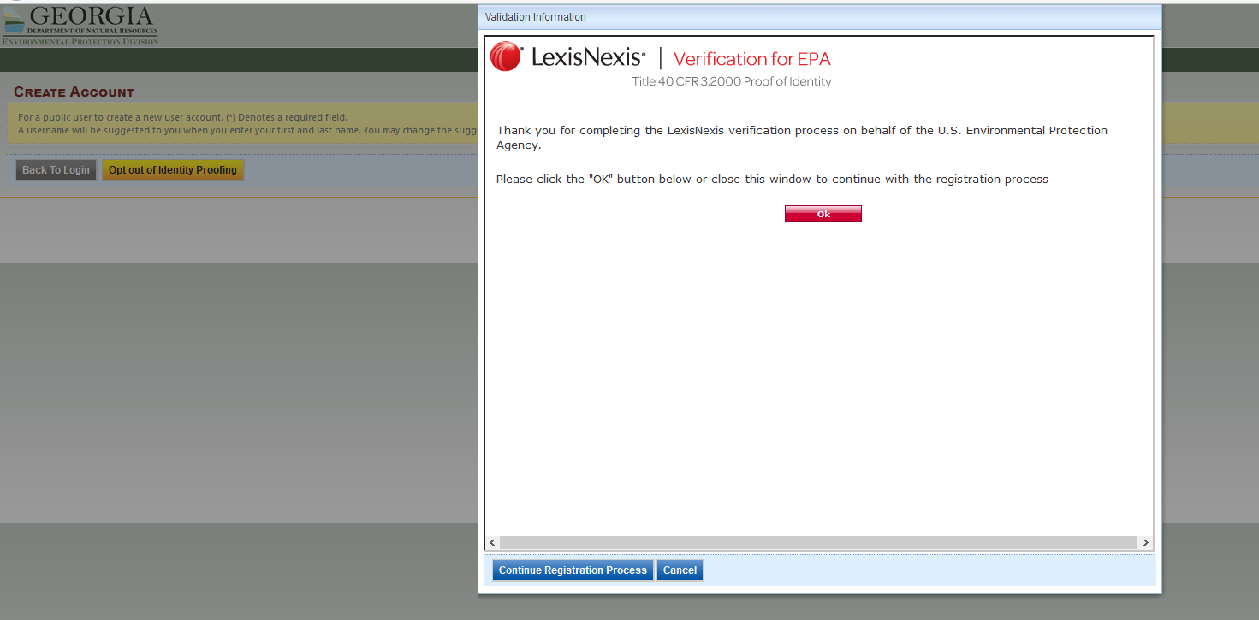
(See page 7 if you have trouble with this step).

- Once your new account has been created, you will receive an email with a temporary password. When you log into your account, create a new password and a PIN. Select “Save” when completed or the page will reset.
NOTE: REMEMBER your password and PIN. When submitting NOIs/NOTs, you will be prompted to use your security question answers and PIN number.
Go to website: https://geos.epd.georgia.gov/GA/GEOS/Public/GovEnt/Shared/Pages/Main/Login.aspx
(Enter your User Name and Temporary Password that was emailed to you to log into your account).
(Create a new password and PIN and then select “Save”).
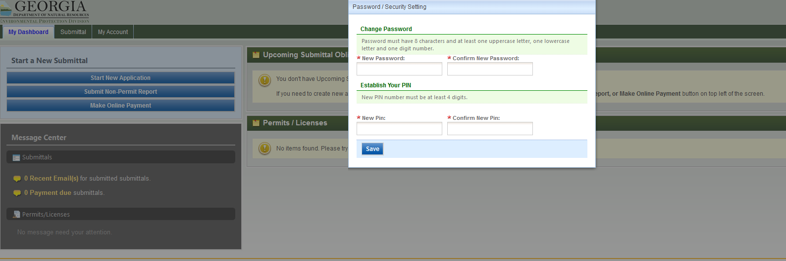

If Identity Proofing via e-Verify Option was unsuccessful:
If an error message pops up after Step 9 like the one below, select “Close” and follow the “Opting out of identity proofing” steps on this page.
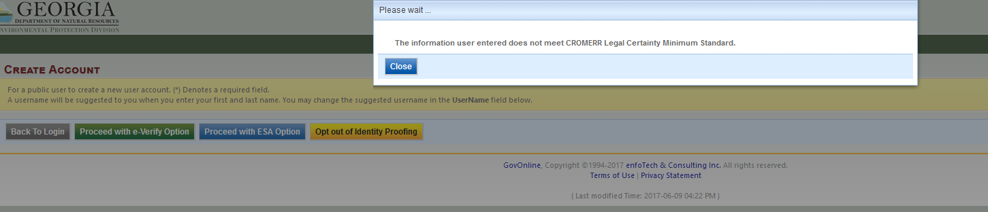

- Select the yellow “Opt out of Identity Proofing” (this will initially bypass the identity proof verification so that you may continue to create your new user account).
