Instructions to Create a New User Account as a Preparer:
- Go to website: https://geos.epd.georgia.gov/GA/GEOS/Public/GovEnt/Shared/Pages/Main/Login.aspx

- Select “Create a new account” on the right side of the screen.
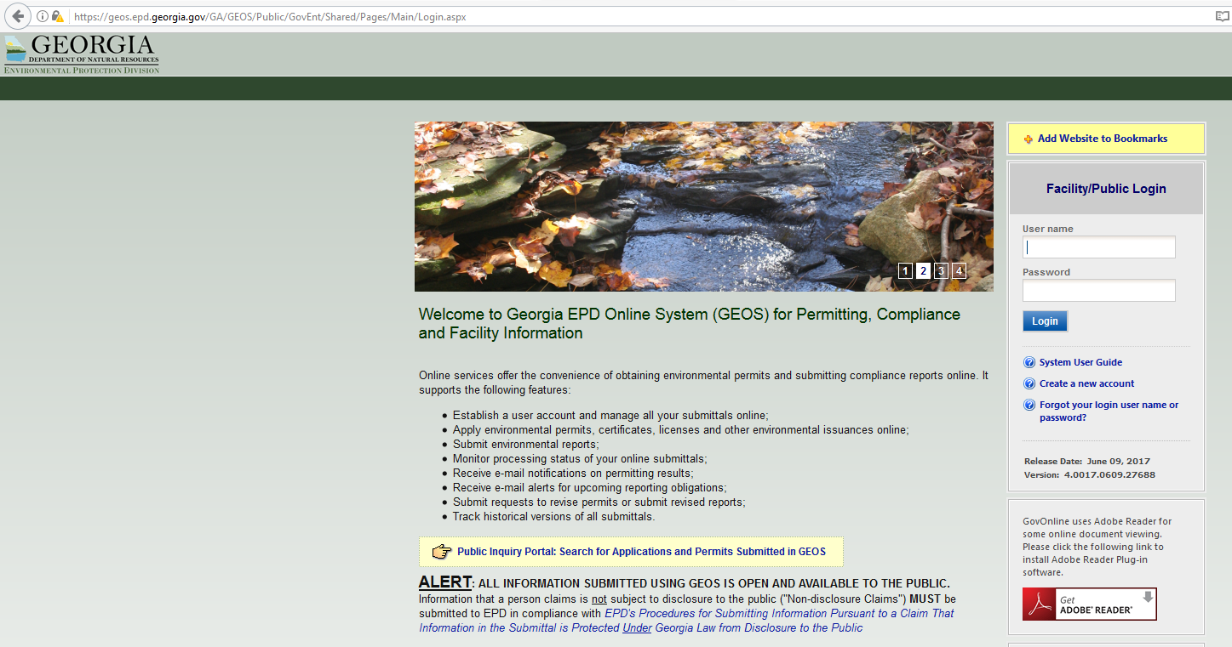
- Select “Preparer,” then select “Preparer” again, and then select “Next.”
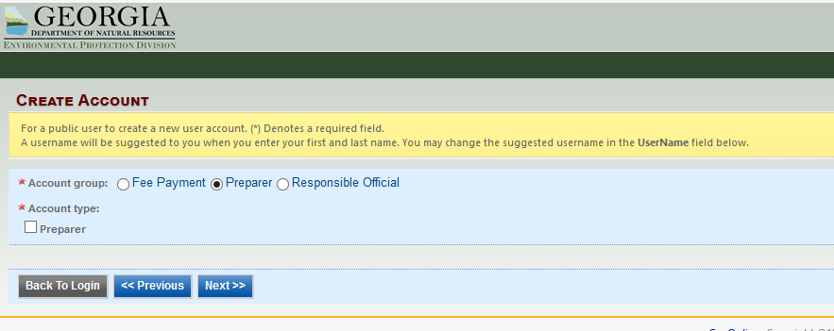

- Answer all 5 of the Security Questions and then select “Next.”
NOTE: REMEMBER your security question answers. When submitting NOIs/NOTs, you will be prompted to use your security question answers and PIN number.
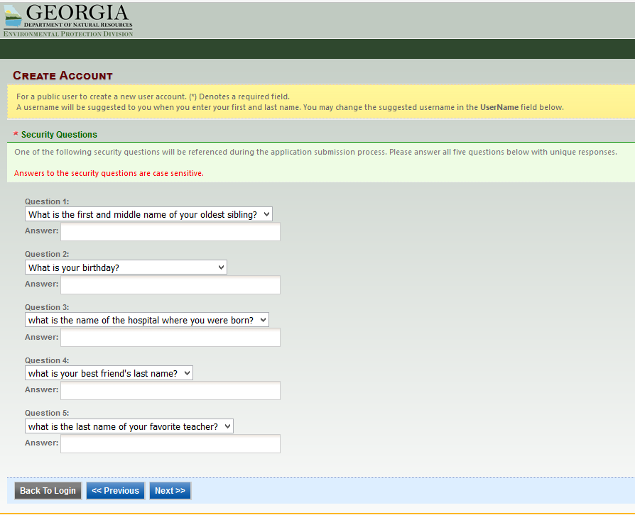

- Enter the characters you see from the orange Submit Query box into the box just below it and then select the yellow “Create Account.”
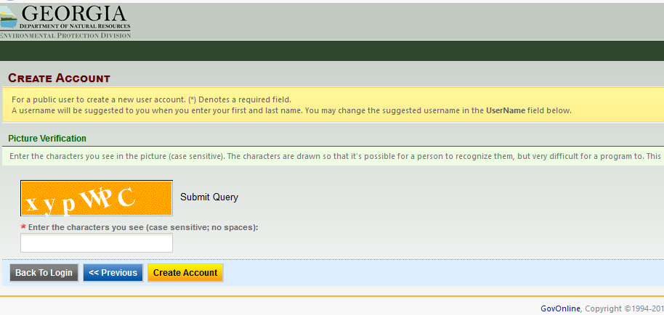

- Once your new account has been created, you will receive an email with a temporary password. When you log into your account, create a new password and a PIN. Select “Save” when completed or the page will reset.
NOTE: REMEMBER your password and PIN. When submitting NOIs/NOTs, you will be prompted to use your security question answers and PIN number.
Go to website: https://geos.epd.georgia.gov/GA/GEOS/Public/GovEnt/Shared/Pages/Main/Login.aspx
(Enter your User Name and Temporary Password that was emailed to you to log into your account).
(Create a new password and PIN and then select “Save”).
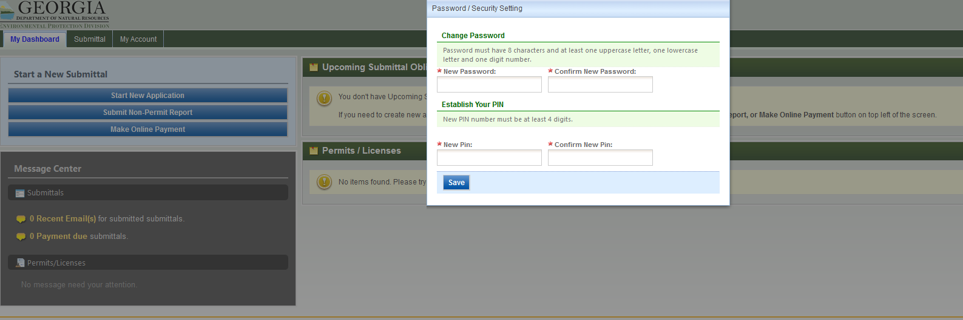

NOTE: ROs must authorize/associate your Preparer Account with at least one facility/site under their account for you to act as their Preparer (ROs will need your email address associated with GEOS).

