March 2019 Climate Summary – Georgia
Lauren Holt, Service Climatologist
State of Georgia Climate Office
Georgia experienced variable temperatures during March and below normal precipitation statewide except for far north Georgia. The overall synoptic pattern remained quite active with consistent swings in temperature and one significant severe weather event. Drought conditions worsened due to the below normal precipitation, particularly across central Georgia.
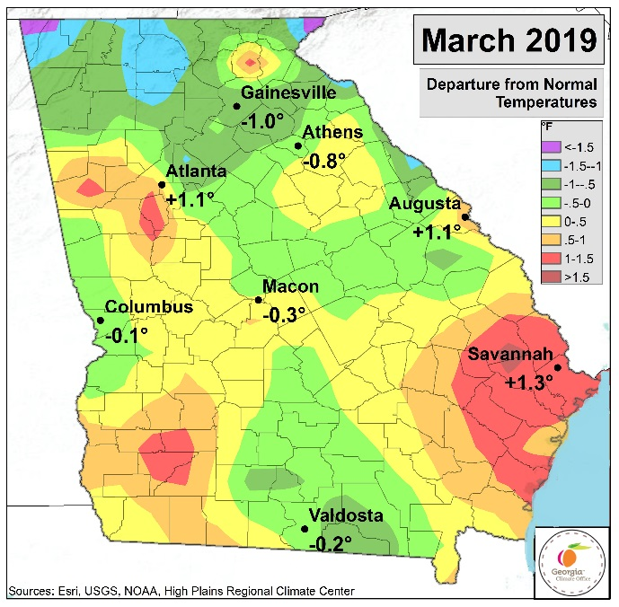
The major climate sites in Georgia that recorded above normal temperatures during March include Atlanta with 55.4°F (+1.1°), Augusta with 57.0° (+1.1°), and Savannah with 60.5° (+1.3°). Athens recorded a monthly average temperature of 53.5° (-0.8°), Columbus recorded 57.7° (-0.1°), and Macon’s average temperature was 56.5° (-0.3°). Since temperatures were so close to normal in March, there were no significant temperature rankings for the month or daily temperature records broken. The station that recorded the highest monthly average temperature of 68.3° was the FARGO 17 NE COOP station in Charlton county. In Rabun county, the MOUNTAIN CITY 2 SW COOP station recorded the lowest average March temperature with 44.5°.
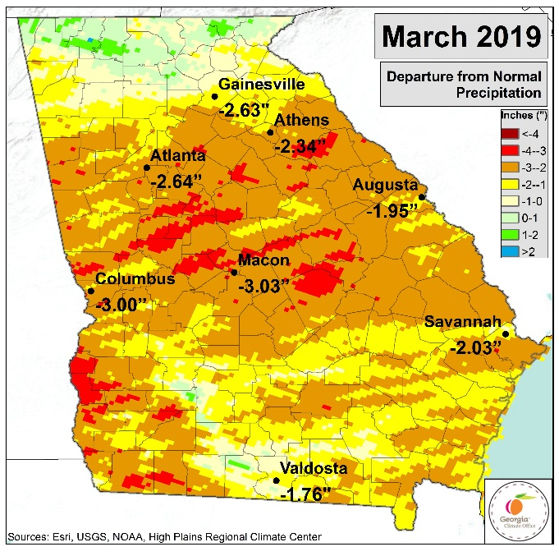
Athens recorded 2.09” (-2.34”) and had its 9th driest March on record. Atlanta was also dry with 2.17” (-2.64”), ranking as 12th driest March on record. Macon’s total monthly precipitation was 1.52” (-3.03”), Columbus recorded 2.46” (-3.00”), Augusta’s total was 2.23” (-1.95”), and Savannah recorded 1.70” (-2.03”). There were no daily maximum rainfall records broken at Georgia’s major climate sites during March. The majority of the highest total monthly rainfall amounts of over 6.00” were recorded in far north Georgia in Gilmer, Rabun, and Union counties. Interestingly, the MOULTRIE 2 ESE COOP station in Colquitt county recorded the second highest total March rainfall with 7.33”.
A major tornado outbreak occurred on March 3rd. A powerful storm system moved through the southeast that produced widespread severe weather and a total of 18 tornadoes across Georgia. The most intense rated as an EF-3 and moved through Muscogee, Harris, and Talbot counties with peak winds of 140 miles per hour. Homes were destroyed and seven injuries were reported. Some counties even saw multiple tornadoes that day. Table 1 lists the location of each tornadic event and their intensity. Additionally, on March 14th, an EF0 tornado was reported in Floyd county that uprooted and snapped trees along a 1.75 mile path. There were only a few other days during March with wind and hail reports.
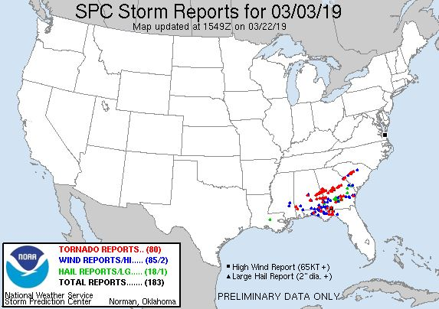
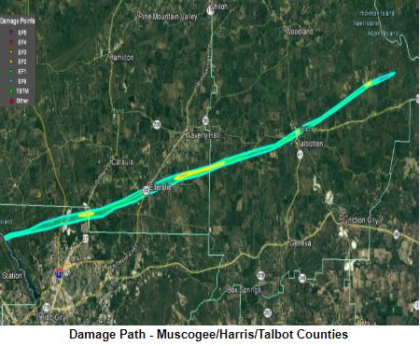
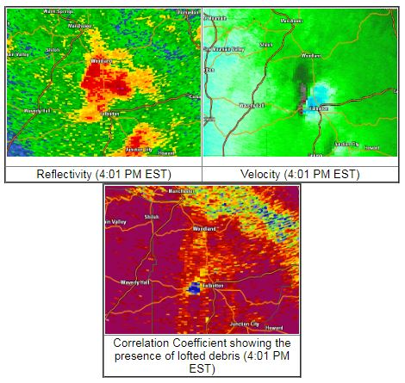
The United State Drought Monitor showed D0 (abnormally dry) conditions in east central Georgia that gradually expanded to cover most of the southern half of Georgia by the end of the month. D1 (moderate drought) conditions were also introduced by mid-month in southeast Georgia.
Storm reports on 3/3/19 via SPC (top), damage path of the Muscogee/Harris/Talbot county tornado (middle), and radar images from the same tornado (bottom)
According to the Climate Prediction Center, El Niño conditions are present and there is currently an El Niño Advisory. Equatorial sea surface temperatures are above average across most of the Pacific Ocean. Weak El Nino conditions are likely to continue through the Northern Hemisphere spring 2019 with about an 80% chance and through summer with about a 60% chance. The CPC’s three-month seasonal outlook forecasts chances for above normal temperature and above normal precipitation statewide.
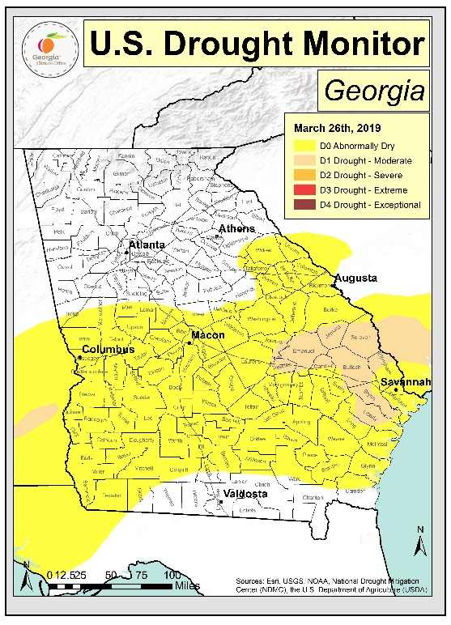

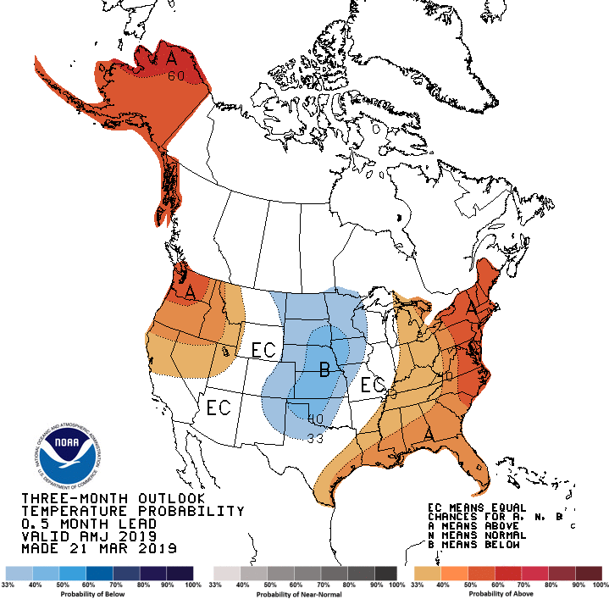
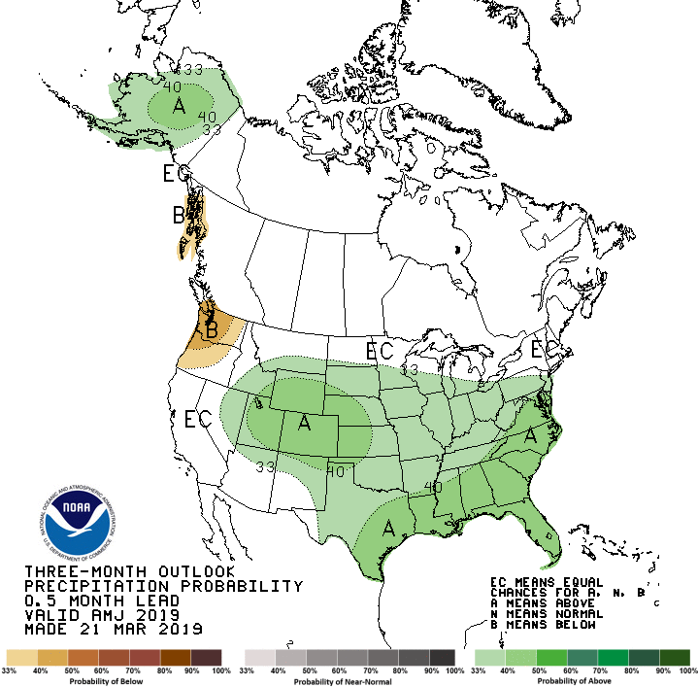
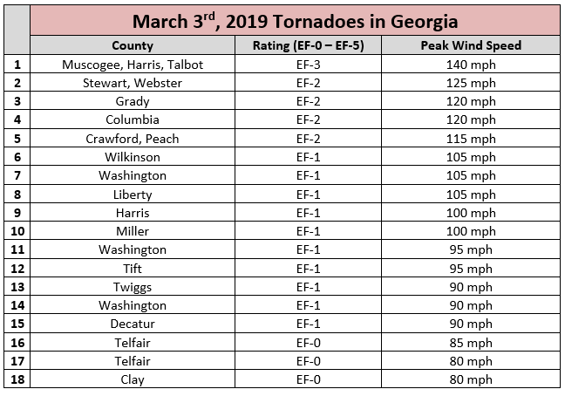
Table 1:

